KC Water
Rules and Regulations for Water Service Lines



May 2026

Introduction

These regulations are established to provide for an orderly growth of the City's water system and to assure equitable treatment to all citizens. All those who have transactions with KC Water are urged to observe these regulations and to cooperate in their enforcement. Section 78.35 of the Code of General Ordinances, Kansas City, Missouri, grants the Director the authority to make and enforce these regulations.

Water mains, service lines and related appurtenances shall meet all currently adopted City of Kansas City, Missouri Plumbing and Building Codes. These codes include limitations set forth in Section 1417 of the Federal Safe Drinking Water Act regarding the definition of “Lead free”. “Lead free” means: when used with respect to pipes and pipe fittings, refers to pipes and pipe fittings containing not more than 0.25 percent (0.25%) lead in contact with and providing transportation of potable drinking water. This standard sets the limit for lead content of these materials at a maxi- mum of 0.25%.

These are generally permissive regulations. This means that rather than including an endless list of prohibitions, the regulations are kept simpler by stating what is allowed. Water service lines shall only be installed in accordance with these regulations, and only by methods, and at times and under the circumstances described in these Regulations. Installations or arrangements other than those described in these regulations are not al- lowed. KC Water anticipates that these regulations will be updated on an annual basis; however, they may be revised sooner if deemed necessary by KC Water.

Table of Contents

SECTION 1.00 – PERMITS 7
  - Property Owner Accounts 7
  - Definition of Permits 7
  - Classification of Permits 7
  - No Work Prior to Permit Issuance 9
  - Plumbers Not to Secure Permits for Others 9
  - Permits Not Transferable 9
  - Expiration of Permits 9
  - Permit Fees 9
  - Delinquent Permits 10
  - Issuance of Permits 10
  - Qualifications of Applicants 10
  - Required Conditions 11
  - Required Procedure 11
  - Plumber's Responsibility 11
  - Permit Cancellation 11

SECTION 2.00 - WATER MAINS 12
  - Definition 12
  - Classification of Mains 12
  - Connections to Water Mains 12
  - Paralleling of Mains 12
  - Operation of Public or City Mains 12
  - System Operating Pressures 12
SECTION 3.00 - WATER SERVICES 13
  - Definition 13
  - Classification of Services and Requirements 13
  - General Installation Requirements 13
  - Installation Requirements for Tap Services 17
  - Installation Requirements for Branch Services 17
  - Combination Service Lines 18
  - Temporary Services 19
  - Partial Services 19
  - Maintenance of Services 20
  - Abandonment of Services - General 20
  - Abandonment of Services for Building Demolition 20
  - Abandonment of Services for Building Alterations 21
  - Reconnection of Services 21
  - Reuse of an Existing Water Service Line 21
  - Service Lines in Suburban Areas 21
  - Relocation of Water Service Lines 22
  - Water Service Lines crossing or near KC Streetcar 22
SECTION 4.00 – TAPPING AND CONNECTING 23
  - Classification of Taps and Connections 23
  - General Requirements for Taps 23
  - Requirements for Corporation Taps 23
  - Requirements for Branch Service Connections 24
  - Requirements for Branch Service Taps 24
  - Requests for Taps 25
  - Request for Water Main Shuts 25
  - Tapping Charges and Connection Fees 25
SECTION 5.00 - METER SETS 26
  - Definition 26
  - Location of Meter Sets 26
  - General Requirements for Meter Sets 26
  - Meter Sets - Small Meters 27
  - Meter Sets - Large Meters 28
  - Permission for Meter Sets 28
  - Meters 29
  - Meter Sets for Serving Other Water Utilities 29
  - Request for Meter Bypasses 29
  - Charges for Exchange of Meters 29
  - Relocation of Meter Tiles and Pits 29
  - Inside Meter Set Relocation Requirement 29
  - Meter Tile Location example 29
  - Double Check Detector and RPZ Detector Check Meters 29
SECTION 6.00 – BACKFLOW REQUIREMENTS 31
  - Backflow Preventer Test Requirements 31
  - Definition of Commercial Construction for Backflow Prevention 31
  - Placement of Backflow Prevention Devices 31
  - Backflow Requirements for Commercial Domestic Water Service Lines 31
  - Placement of RPZ Backflow Prevention Devices 31
  - Enclosure Requirements for RPZ Backflow Preventers 31
  - Backflow Requirements for Full Flow Fire Meters 31
  - Backflow Requirements for Fire Protection Service Lines 31
  - Backflow Requirements for Lawn Irrigation Systems 32
  - Backflow Requirements for Existing Commercial Domestic and Fire Protection Service Lines 32
  - Testing of Backflow Prevention Devices 32
  - Approved Backflow Prevention Devices 32
  - Removal and Break Down of Backflow Vaults 32
SECTION 7.00 – INSPECTION 33
  - Water Service Lines Inspection Requirements 33
  - Definition of Inspection 33
  - When Required 33
  - Scope of Inspection 33
  - Time of Inspections 33
  - Request for Inspection 33
  - Conditions for Inspection 33
  - Inspection of Large Services 34
SECTION 8.00 – MISCELLANEOUS 35
  - Interpretation of KC Water Regulations 35
  - Request for Information 35
  - Damage to KC Water Property 35
  - Repair or Relocation of Water Facilities 35
  - Discrepancies - Plumber's Responsibility 36
  - Request for a Water Main Shut, to Connect or Abandon Services 36
  - Lead Ban 37
  - Meter Prices 39
8.9 Water Connection Charges 40
APPENDIX 41
6202 Outside Installation for 3/4" and 1" Services 42
6203 Detail of 5/8", 3/4" and 1" Meter Settings 43
6204 Detail of Service Box (Curb Box) 44
6205 Detail of Vault for Less than 2" Backflow Preventer 45
6206 Detail of Tile Box for 5/8", 3/4" and 1" Meter Settings 46
6207 Water Meter Settings for Single 1-1/2" and 2" Meters Settings 47
6208 Cast-in-Place or Pre-cast Vault for 2" & Larger Backflow Preventers 48
6209 Cast-in-Place or Pre-cast Meter Pit & Setting with Bypass for Single 3" thru 10" Meters 49
6210 Cast-in-Place or Pre-cast Meter Pit & Setting for Double 4" and 6" Meters 50
6213 Flexible Coupling Adapter & Mechanical Joint Retainer Gland 51
6214 Combination Service Lines 52
6215 Cut In Tees on Service Lines 53
6216 Excavation Details for Corporation Taps 54
6217 Cast-in-Place or Pre-cast Meter Pit & Setting with Bypass for 6" Through 10" Fire Flow Meters 55
6218 RPZ Backflow Preventer 56

SECTION 1.00 – PERMITS

  - Property Owner Accounts No permit shall be issued to a licensed master plumber on behalf of an owner unless all accounts are current and paid in full.

  - Definition of Permits A Water Service Permit is a written document issued by KC Water authorizing work to be performed. The purpose of these permits is to ensure order in the growth of the water system and that only qualified persons engage in this work. Permits are required under Section 78-28 of the Code of General Ordinances, Kansas City, Missouri.

  - Classification of Permits Permits are of seven (7) kinds, defined as follows:

- New Service Permits are required where taps or new connections to a water main are to be made, and new services are to be installed.

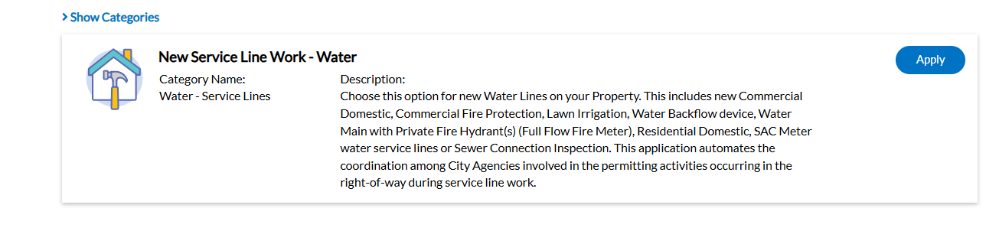

- Repair Permits are required where an existing service, whether on public or private property, is to be altered, extended, repaired, or renewed from the first valve to the building, or fixtures or appurtenances added thereto or detached therefrom. When an existing building is being renovated or is undergoing a building addition, and the existing water service line(s) will be reused, the water service line(s) and related appurtenances shall meet the most current version of KC Water Rules and Regulations. When work is to be done to any portion of a commercial building domestic or fire protection water service line, whether on public or private property from the first valve to the shut off valve inside the building, up to and including the backflow preventer, the water service line and related appurtenances shall meet the most current version of KC Water Rules and Regulations. Residential and Commercial service(s) shall include proper taps connections on the water main for all existing 3/4” and 1” water service lines. Commercial and Residential service (s) shall include cutting in a minimum 6” tee and installing the proper isolation valves on the water main for all existing 1-1/2” and larger water service lines. See section 3.4 for installation requirements for tap services and section 3.5 for the installation requirements for branch services. See sections.
5.4 (c), 5.5 (c) and 8.4 (e)
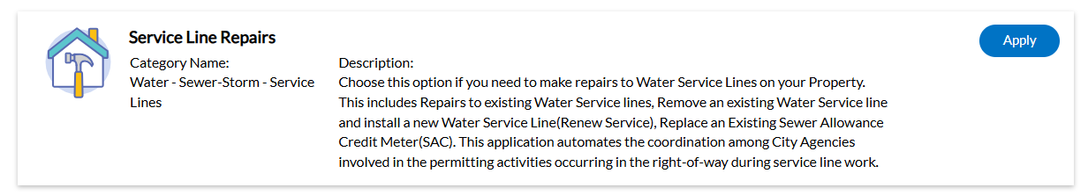

- Backflow Permits are required on all new and existing commercial, industrial, fire protection and lawn irrigation water service lines which are required to have approved backflow prevention assemblies installed in the line.

- Kill Permits are required where an existing service (water, sanitary or storm) that is to be abandoned or disconnected is connected to a public main, whether on public or private property. The service that is to be abandoned or disconnected shall be killed at the main, as determined by KC Water. All accounts must be paid in full at time of permit issuance. A Kill Permit request for a fire line will not be processed without a letter of permission from the building official unless it is associated with a building demolition permit or with a fire line replacement permit.

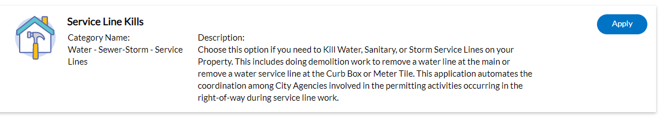

- Renewal of Expired Permits is required when the work on a water line has not been completed and inspected at the expiration of the original permit (180 Days).

- Disconnect at Curb Permits are only allowed when a building is being demolished, building back plans have been submitted on CompassKC, and the service line will be reused within one year. The service line shall be disconnected, cut, and capped on the house side of the curb box or meter tile. All accounts must be paid in full at time of permit issuance. See section 3.11 (c)

- Sewer/Storm Connections inspection fee shall be as specified in the Code of General Ordinances, Kansas City, Missouri, Section 78.28.

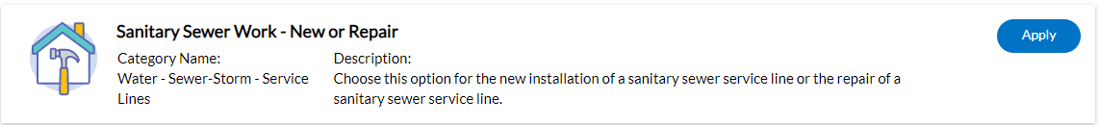

  - No Work Prior to Permit Issuance No work in connection with the tapping of or connection to any water main or the introduction of water into any premises (public or private) shall be done, nor shall any water service line be altered, repaired, replaced, or extended without prior issuance of a permit authorizing the performance of such work. Any work that has been started or completed without first obtaining a permit for such work, shall have the fee specified for such permit tripled. Connecting to a public water main without the water main being released for connections or with- out obtaining a permit and paying the connection fees for such work, shall have the permit and connection fees specified tripled. When the plumber must perform emergency work during other than normal working hours, KC Water (Emergency Dispatch) shall be notified by telephone at 816-513-1313 prior to the start of such work and the plumber shall apply for the permits on CompassKC that day. This provision shall not be construed as permission to begin work with- out the required permits. See section 7.4 for inspection to be performed during other than normal working hours.
  - Plumbers Not to Secure Permits for Others A Master Plumber's or Journeyman Plumber's license is not transferable, and any Master Plumber shall subject himself to suspension if he at- tempts or procures a water permit for the benefit of anyone other than himself. The Master Plumber is responsible for all work done that is described under the permit issued.

  - Permits Not Transferable Permits are not transferable and are only valid for the applicant to whom it is issued and for the job described thereon.

  - Expiration of Permits When a permit is issued the permit will be valid for one hundred eighty (180) consecutive days. If the work has not been completed on the water line at the expiration of the permit, the permit can be renewed for an additional one hundred eighty (180) days by making a request in writing to the Water Service permit desk. If the work has not been completed after one (1) year of issuance of the permit, a new permit will be required. Any work abandoned during the one hundred eighty (180) day period or during the extended period will require a new permit before commencing at one-half the fee of the original permit. Permit fees for expired permits will not be refunded. This includes backflow permits.

  - Permit Fees All permit fees, plan review fees, charges for connections to water mains, meters, and meter setting will be paid by the applicant at the time of procuring the permit.

- Permit fees, sewer connections inspection fees and plan review fees shall be as specified in the Code of General Ordinances, Kansas City, Missouri, Section 78.28, and shall not be re- fundable.

- Charges for branch service line to water mains, meters and meter setting shall be in accordance with the schedule of prices published by KC Water, at the current time. If the permit is not used then, those charges may be refunded as long as the permit has not expired.

  - Delinquent Permits No permits will be issued to anyone who is holding a delinquent permit. A permit will be considered delinquent when any of the following criteria are met:

- Failure to rectify a rejection on inspections including final inspections occurring within one year, subsequent the completion of work by the plumber.

- No permit shall be issued to an applicant that owes any fees or for any or all properties where monies are owed to KC Water until all accounts and fees are paid in full.

- Any unpaid job orders or other amounts owed to KC Water.

  - Issuance of Permits KC Water shall issue permits to qualified applicants only after all the requirements are satisfied. Permits are issued subject to a city water main being directly opposite or adjacent to the building to be served. Failure of the applicant or the property owner to pay a bill for services rendered by the City shall be a basis for denial of further permits until such bill or bills is paid. Persistent violation of the provision may be considered cause for revoking the City issued licenses held by the offender. Property owners who fail to pay all applicable monthly charges and fees on their accounts for water services to the property(s) may be cause for the water services to be disconnected at the discretion of KC Water.

Permits applied for on CompassKC shall be issued within 24 hours of application (during normal business hours) if the public works portion of work has been issued and paid in full.

Plan review. The director is hereby authorized to establish the following fees and charges for water service plan reviews:
A fee of $110.00 for water service plan reviews involving no more than ten service connections.
For water service plan reviews involving more than ten service connections, an additional charge of $12.00 for each connection greater than the ten connections included in the charge referenced in subsection(f) (1)
A charge of $65.00 if plans are rejected and must be resubmitted for review due to deficiencies in the original plan.
  - Qualifications of Applicants Applicants shall be prepared to show proof of qualification at the time of application and shall procure permits for themselves and no other. Permits shall be issued only to the following:

- A Master Licensed Plumber who may apply as a firm, partnership, or corporation. The term "Master Plumber" as used herein shall be as defined in the Building Code.

- Licensed Automatic Fire Sprinkler Contractors (Class one or Class two) who are to install fire protection systems only as described in the Building Code.

- Contractors who are performing work under City contract that required them to modify existing water facilities may be issued permits for the work defined in the contract.

- Licensed Wrecking / Demolition Contractors may be issued kill permits for disconnecting 3/4" and 1” corporation taps only. Branch service line connections 1-1/2” and larger and spider taps shall be disconnected from the water main by a Licensed Master Plumber. See section 3.12(b)

  - Required Conditions Prior to receiving the permit, the applicant must perform the following:

- Complete application and billing information on CompassKC or working directly with permit staff for walk-in customers. Plans signed and sealed by a registered professional engineer, licensed in the State of Missouri, are required for commercial connection applications.

- Obtain an excavation permit from Public Works, when required.

- Pay for permit and obtain receipt.

  - Required Procedure Each application for a permit on CompassKC and shall be signed by the applicant, as defined in Section 1.10, or their duly authorized agent for the licensed master plumber; it shall state in precise terms the work to be done under the permit. In addition, each application shall contain the following information:

- The name of the person for whom the work is to be performed or the owner of the property served.

- The correct address and other legal description where work is to be performed. House num- bers must be assigned as approved by the City Planning and Development Department on the building permit. Building permit must also be available, where applicable.

- On all commercial projects the plumber must have approved plans that have been reviewed and accepted by KC Water Permit & Development Division.

  - Applicant’s Responsibility Applicant shall be responsible for any damage, defective workmanship performed, or material furnished for a period of one year from the date of the last approved inspection.

  - Permit Cancellation When a Master Plumber, Licensed Wrecking Contractor, or Fire Sprinkler Contractor is holding a permit in which no work will be done, the Master Plumber, Licensed Wrecking Contractor or Fire Sprinkler Contractor must cancel the permit. This will be accomplished by giving notice to KC Water Permit & Development Division by phone, e-mail or U. S. mail. The Director of KC Water shall be authorized to cancel any permit issued for cause with no right of appeal.

SECTION 2.00 - WATER MAINS

  - Definition A Water Main is the water pipe, fittings, valves, boxes, and appurtenances installed as an integral part of the distribution system, but not including hydrant assemblies and water service lines.

  - Classification of Mains Water Mains are classified functionally as Transmission (Feeder) Mains and Distribution Mains. A further classification into City Mains and Private Mains is also made. These mains are further described as follows:

- A Transmission Main is a water conduit that is used for the transportation of water from one part of the water system to a more remote part. These mains are normally sixteen (16) inches in diameter and larger, or as determined by KC Water.

- A Distribution Main is a water conduit that is connected between and from Transmission Mains and is the principal means of supply for customers through a service line connection. These mains are normally twelve (12) inches and smaller in diameter, or as determined by KC Water.

  - Connections to Water Mains Water service connections to Transmission Mains are not per- mitted. Connections to Distribution Mains shall be made as provided in these rules and regulations, "Section 3.00, Water Services."

  - Paralleling of Mains When a new City Main is laid paralleling an obsolete existing main, connection between the new City Main and existing individual services will be made at the expense of the party causing the work to be performed, as determined by KC Water, and the obsolete main will be abandoned. This work will include any necessary extension or abandonment of existing services in accordance with these Rules.

  - Operation of Public or City Mains Operation of mains, valves or other appurtenances shall be performed only by KC Water Personnel. Requests by plumbers for the shutting down of mains shall be made a reasonable time in advance, and shutdown will normally be performed during regular working hours or at the discretion of KC Water unless a request stipulates otherwise. When shutdowns are made for the benefit of the person making the request, they will be charged for this service on the basis of the prevailing labor and equipment rates, as determined by KC Water.

  - System Operating Pressures The normal operating pressure in the KCMO Water Service Department system can vary widely due to the size of the system and the topography of the service area. The average static pressure in the system is approximately 40 psi, with an expected minimum residual pressure of 20 psi.

End of Section

SECTION 3.00 - WATER SERVICES

  - Definition A Water Service is the piping and appurtenances installed from the water main to that portion of the interior piping that is regulated by the Building Code. A yard hydrant and drinking fountain shall be considered as a lawn irrigation system and shall be permitted as such.

  - Classification of Services and Requirements A meter shall be installed on all Domestic Tap Service Lines and Branch Service Lines connected to a public water main. A backflow preventer shall be installed on all lawn irrigations, yard hydrants, drinking fountains, commercial domestic and fire protection water service lines that is connected to a public water main. Water service lines are classified into two categories: Tap service Lines and Branch Service Lines. The components of Tap Service Line are a corporation stop, copper pipe, HDPE pipe, curb stop and box, unmeasured flow reducer, meter, meter yoke, meter stop valve, pressure reducing valve, and backflow preventer if required. The components of Branch Service Line for water services are normally a tee, three (3) key operated gate valves (that open in a clockwise direction), and two (2) solid sleeves installed on the main, a valve box, pipe, meter, meter stop valves and drain connections complete with valves and bypass piping and backflow. Branch Service lines shall be for domestic water service or private fire protection service in accordance with the regulations herein stipulated. Tap service lines may use High Density Polyethylene (HDPE or PEX) pipe installed five (5) feet after the meter to the building and shall be SDR 9 and meet AWWA C901 or C904 regulations and copper tubing size (CTS) standards. High Density Polyethylene (HDPE or PEX) pipe may be installed on lawn irrigations five (5) feet after the backflow. HDPE or Cross-Linked Polyethylene (PEX) Type “A” pipe may be in- stalled.
  - General Installation Requirements All service lines shall conform to the following requirements:
- Service line connections, curb box, and meters are to be installed within lines roughly parallel to the footprint of the building foundation lines to be served. The curb box or roadway valve and the water meter shall be located in front of the building to be served.
- Service lines are to run perpendicular to the main, from the main to the curb box. Service lines shall not be installed parallel to the public right of way.
- Service lines shall be laid at least ten feet horizontally from any existing or proposed drain or sewer line. Should local conditions prevent a lateral separation of ten feet, a water service line may be laid closer than ten feet to a storm or sanitary sewer line, provided that the service line is laid in a separate trench or on an undisturbed earth shelf located on one side of the sewer line and at such an elevation that the bottom of the service line is at least eighteen inches above the top of the sewer line. When itis impossible to obtain vertical or horizontal separation, the sewer line must be re-laid and constructed in accordance with details for such sewer line crossings in the Standards and Specifications for Water Main Extensions and Reloca- tions published by KC Water and shall be pressure-tested to assure watertightness before backfilling.
- Where service lines must cross over sewers, storm drains, water, or gas lines, the service line must be laid at such an elevation that the bottom of the service line is at least eighteen (18) inches above the top of the sewer or other pipe. This vertical separation must be maintained for that portion of the service line within ten feet horizontally of any sewer line that it crosses, said ten feet to be measured as the clearance from the service line to the sewer.

- Service lines shall have a cover of not less than four (4) feet or more than five (5) feet, unless obstructions require deeper excavation for clearance that is approved by KC Water.
- No service line will be less than 3/4 inches in diameter; a 3/4” service line shall serve only one residential unit or commercial building. A 1” service line can serve a maximum of two residential units for commercial buildings. Each residential unit or commercial building shall have a 1” curb stop installed and shall be reduced to a 3/4” service line after the curb stop.

- No water service line will be less than 1-1/2” in diameter where three or more residential units or Commercial building will be served by one domestic service line and meter.
See section 3.05 (b) for installation requirements for branch service lines.

- Distances between branch services shall be a minimum of five (5) feet, or as approved by KC Water.

- A state approved backflow preventer assembly is required on all commercial service lines, irrigation systems, yard hydrants, drinking fountains, fire protection lines, private fire hydrants lines or other lines constituting a potential cross connection to the public water supply. The backflow preventer for domestic service lines shall be as manufactured by Flowmatic “RPZ” or approved equal. Check valves for all fire protection service lines shall be Double Check Detector Assemblies as manufactured by Watts with meters as manufactured by Schlumberger or approved equals. Fire protections systems that inject chemicals shall have an RPZ (Reduced Pressure Zone) Detector Check backflow prevention device installed. The Double Check Detector backflow preventer device meter shall be AMR compatible, the lids for the meter tile shall be a composite material that is transparent to radio frequency transmission from the KC Water automatic meter reading system. See sections 5.3 (j), 5.4 (c), 5.4 (d), 5.5 (c), 5.5 (d), 5.14, 6.7 and 8.4 (e)
- A lawn irrigation system, yard hydrant or drinking fountain cannot be tapped from inside a meter vault or before the containment backflow preventer assembly.

- All double check assemblies required on lawn systems, yard hydrants and drinking fountains will be installed in a separate approved meter pit, sized appropriately, i.e. a 2” backflow preventer requires a 2” meter pit.

- Service lines shall serve only one lot or tract and shall not cross separate lot lines or tracts, even if said lots or tracts are owned by same person.

- Water connections for critical care or other facilities that require uninterrupted service shall be designed to have two separate services from water mains in two separate streets whenever possible, so that a water main shut down in one street will not interrupt service to the facility.

- Service lines for all fire sprinkler systems, or for domestic use on all multi-floor buildings (three or more floors), should be designed to include private pumping systems necessary to properly maintain ade- quate pressures in the service line, all floors of the building, and public mains at all times. See section 2.6.

- Branch service lines for fire sprinkler systems shall have a minimum connection of a 6” tee to the public water main and may be reduced after the 6” shut off gate valve on the branch of the service line. The fire protection service line shall be a minimum of a 4”, a minimum 4” shut off gate valve shall be installed immediately as the service line enters inside the building. A minimum 4” Double Check Detec- tor backflow preventer shall be installed inside the building immediately after the building shut off
gate valve or in a meter tile or pit on private property one foot inside the property line. The inlet valve on the backflow assembly cannot serve as the building shut off valve. The Double Check Detector backflow preventer device meter shall be AMR compatible, the lids for the meter tile shall be a composite material that is transparent to radio frequency transmission from the KC Water automatic meter reading system. See sections 3.3 (i), 5.3 (j), 5.4 (c), 5.4 (d), 5.5 (c), 5.5 (d) 5.14, 6.7 and 8.4 (e).
Note: Critical care Facilities and multi-floor buildings (3 or more floors) should be designed to include a private pumping system on all domestic and fire protection service lines to properly maintain adequate pressure at all times. Water main minimum pressure is 20 psi.
If it is determined that a private pumping system (booster pump) is not needed on the domestic and/or fire protection service lines, a letter shall be signed and sealed and submitted by a Registered Professional Engi- neer licensed in the state of Missouri listing the calculations and safety factor used in making the determination. The letter shall be submitted to KC Water.

Water Flow Test Data Letter

Service lines for all fire protection / sprinkler systems shall be designed to properly maintain ad- equate pressures and flows in the system at all times. See section 2.06. Applicant must submit a separate letter with the following statement signed and sealed by a Professional Engineer, regis- tered with the Missouri Board for Professional Architects, Engineers and Land Surveyors.

“The water flow test data shown above are the values determined by testing on the date and time indicated. Due to the daily and seasonal fluctuations inherent in the KCMO water supply, the flow and pressure available at other times may be less. All users of this data are responsible to apply an adjustment to the water flow test data where appropriate or as required by NFPA 13 and any other applicable codes, standards, ordinances or engineering practice.
This form shall be signed by the responsible design professional and submitted with the project design documents for permit application.

KCMO PROJECT #

KCMO PROJECT NAME

Address:

NAME:

MO P.E. LICENSE #

SIGNATURE:

Note: Effective May 1, 2015, KC Water shall witness and oversee fire hydrant flow test by a third party. The requester is responsible for hiring a third party to perform the test; flow test data cannot be more than two (2) years old.

  - Installation Requirements for Tap Services All Tap Service Lines shall conform to the following requirements:

- All tap service lines shall conform to the latest Federal Specification for Type K flexible copper tubing and HDPE piping (see section 3.02). All tap service lines within 3’ of the water main shall be wrapped in polyethylene encasement. Polyethylene encasement shall be as specified in the most recent version of the Standards and Specifications for Water Main Extensions and Relocations as published by the Water Service Department.

- The connection of the tap service line to the corporation stop shall be made by means of a dielectric flared fitting (provided by plumber) or approved dielectric compression coupling, A.Y. McDonald 4755db, or approved equal.

- The line shall be laid with an expansion loop located as near to the corporation stop as possible. This loop shall be in the form of a half S bend and be at least six (6) inches off the centerline of the run.

- No union shall be permitted between the corporation stop and the curb stop.

- Service lines installed in parallel in the same trench shall have a minimum of 5’ of separation.

- All new and existing tap service lines shall be fitted with a tee-headed curb stop located within one foot behind the curb, or if there is no curb, on city property with prior approval of KC Water, and opposite the tap connection. The curb stop shall be fitted with an approved extension rod that is twelve inches long, and the top of the extension rod must be at least twelve inches below the top of the lid. Curb stops shall be non-bleeder ball type with stops at both ends and without contact between metal parts, utilizing Teflon coating on seals and "0" ring rubbers. The curb stop shall not require lubrication. Tee head must turn 90 degrees counterclockwise for "on" position and when on, will be perpendicular to curb. Curb stop shall be A.Y. McDonald 6100-22 or approved equal.

- Each curb stop must be fitted with a curb box. Curb boxes shall be of an approved material of uniform strength and thickness and shall be made with two sections that will permit an adjustment of not less than one foot in length so that the overall length can be varied from four to five feet. The lower section of the box shall be white, have a minimum internal diameter of three (3) inches and have a closed base designed to hold the curb stop in the center. Cast Iron boxes are required in driveways and sidewalks or any other paved area. Curb boxes shall be a minimum of five (5) feet from service line valves. Curb box will be Armor 110175-22 or approved equal.

- Each tap service line shall be fitted with a stop valve immediately on entering a building. The stop valve shall be A.Y. McDonald 6001 or approved equal.

- Unless otherwise permitted, a pressure-reducing valve (PRV) will be installed in all tap service lines. On outdoor meter sets, this PRV will be located on the house side of the stop valve. The PRV shall be designed to "fail open" and to permit draining of the system and shall be Watts 25aubZ3 or approved equal.

  - Installation Requirements for Branch Services All branch service lines shall conform to the following requirements:

- Branch service lines two inches and smaller in diameter shall conform to the latest Federal Specifications for Type K flexible copper tubing. Branch service lines larger than two inches shall be ductile iron, wrapped in polyethylene, and in accordance with the latest revision of KC Water's Standards and Specifications for Water Main Extensions. Only flared connections or compression couplings shall be permitted on Copper Branch Service lines. No sweat fittings shall be permitted on any portion of a branch service line.

- Branch service lines one-and-one-half inches and larger in diameter for domestic water services or fire protection lines shall be connected to the main by cutting in a minimum 6” branch service tee, installing three gate valves, and two solid sleeves on the main. Line valves on the main shall be the same nominal size as the main. All buried valves shall turn clockwise to open and shall be in accordance with current Standards and Specifications for Water Main Extensions as published by KC Water. However, at the discretion of KC Water, cutting-in tees are not required for lawn irrigation, yard hydrants or drinking fountain service lines.
(c) The valves on branch service line connections shall be fitted with a roadway box that conforms to current Standards and Specifications for Water Main Extensions as published by KC Water. Valves shall also be fitted with a valve base where necessary.
(d) All new and existing branch service lines shall be fitted with a stop valve immediately on entering inside a building. The stop valve shall be a gate valve on all service lines over two (2) inches. Two inch and less will be a ball type valve. When a backflow assembly is installed inside the building, the inlet valve of the backflow assembly cannot serve as a stop valve. The backflow preventer must be installed on the service line immediately upon entering the building after the stop valve. Where the backflow preventer is an RPZ, there must be a floor drain located within twenty (20) feet of the device. Proper material shall be maintained one foot past the backflow device, branch service lines two inches and smaller shall type K copper or HDPE. Branch service lines for private mains or fire loops, larger than two inches shall be ductile iron pipe a minimum of five feet past the backflow device, then may transition to C-900 PVC-SDR14
(e) Branch service lines for fire sprinkler systems shall have a minimum connection of a 6-inch branch service tee to the public water main and may be reduced to a 4-inch after the 6-inch shut off gate valve on the branch of the service line or one foot after the shut off gate valve and the double check detector backflow preventer inside the building. The inlet valve on the backflow assembly cannot serve as the building shut off valve. The Double Check Detector backflow preventer device meter shall be AMR compatible, the lids for the meter tile shall be a composite material that is transparent to radio frequency trans- mission from the KC Water automatic meter reading system. See sections 3.3 (i), 5.3 (j), 5.4 (c), 5.4 (d), 5.5 (c), 5.5 (d) 5.14, 6.7 and 8.4 (e).
(f) Branch service lines for private service mains supplying private fire hydrants shall have a minimum connection of a 6-inch branch service tee to the public water main, shall have a minimum 6-inch full flow fire meter and shall conform to the newest edition of NFPA 24 (National Fire Protection Association) standards for installation of Private Service Mains and Their Appurtenances. All private fire hydrants must be painted red.
(g) When a fire protection water service line serves more than one new or existing building, a shutoff gate valve (the same size as the service line, minimum being a 6-inch) shall be installed immediately as the service line enters inside each building. A full flow fire meter and a double check backflow preventer shall be installed on the fire protection service line.

  - Combination Service Lines (Not Recommended):

Service lines to supply domestic water may be connected to a branch service line used for fire protection only with advance permission of KC Water and only under the following conditions:

- When there is not enough space to install both branch service lines on the public water main.

- A registered Professional Engineer licensed in the State of Missouri must certify that the water in the service line will turn over every two days.

- An approved backflow assembly must be installed on both the Fire Protection and the domestic water service lines. The fire protection backflow preventer shall be installed outside on private property in a vault, the RPZ backflow preventer shall be installed on the domestic water service line immediately as the service line enters inside the building after the building shut off valve. Both must be tested upon installation. See section 6.10

- Connection shall be made on private property in a location having the prior approval of KC Water. A minimum of a four-inch gate valve shall be installed on the domestic branch service line tee off the fire protection service line.

- Service lines for domestic water shall be considered either tap service piping or branch service piping and shall be subject to the provisions of Section 3.3 and Section 3.4 or Section 3.5, whichever governs.

- The combination service line shall have the meter pit located entirely on private property with the exact location to be determined during the plan review process.

- A combination service line with one connection from the public main serving the domestic water service and private fire hydrant(s) shall have a minimum 6-inch full flow fire meter installed. Immediately after the meter a backflow prevention device shall be installed in a vault or in an above ground heated enclosure at the Discretion of KC Water. Apartment buildings shall install an RPZ in an above ground heated enclosure immediately after the full flow fire meter on private property.
See sections 5.4 (c), 5.5 (c) and 8.4 (e).

  - Temporary Services Temporary services will be permitted as stated in the Code of General Ordinances, Kansas City, Missouri.

- A deposit will be required for temporary services, to be obtained by new permit application in writing by the property owner. Disconnection and abandonment of temporary services shall be in accordance with the rules herein set forth; failure to abide by these rules will result in forfeiture of all deposits.

3.8 Partial Services When a service line is installed for future use, it shall be installed past the curb stop, water meter and backflow preventer; the service line may be plugged or capped five feet past the backflow preventer device. A repair permit will be required to complete the service line.

  - Maintenance of Services KC Water shall maintain all service lines from the main to and including the first valve, but not the house side connection thereto. On tap service lines the first valve is the curb stop. The owner shall maintain the service line after the first valve to assure a safe potable water supply and in a structural condition that will permit KC Water employees to perform normally assigned duties. Maintenance of meter tiles and pits shall be the responsibility of the property owner and in accordance with Section 5.5 and 5.6. Maintenance of service lines in suburban areas shall be in accordance with Section 3.15. See sections 5.4 (c), 5.5 (c) and 8.4 (e).

Repairs to any section of the water service line shall be performed in an approved manner using approved materials. An insulating bushing (dielectric coupling) shall be used when a new copper service line is connected to an existing service line other than copper. All water service lines repairs and related appurtenances shall meet the most current version of KC Water Rules and Regulations.

When the existing water meter is inside a commercial building and a repair permit is obtained to make repairs to any portion of the water service line whether on public or private property the meter shall be relocated outside in a meter tile or pit on private property at the time the service line is repaired.

When the existing water meter is inside a residential home and a repair permit is obtained to make repairs to replace the entire service line from the curb stop to the stop and waste valve inside the building the water meter shall be relocated outside in a meter tile or pit on private property, one foot inside the property line. The water meter may remain inside the residential home on minor service line repairs.

  - Abandonment of Services - General Service lines may be disconnected at the main, under the provisions of Section 78-23 of the Code of General Ordinances, Kansas City, Missouri. In addition to these provisions, service lines shall be disconnected at the main, curb box or meter tile at the discretion of the KC Water in the event of building demolition or alteration. Abandonment of services shall be performed under a Kill or a Disconnect Permit in the following manner:

- On tap service connections, the corporation stop shall be uncovered, the corporation stop turned off, the service line disconnected, and the threads cut off of the corporation. All curb boxes, meter tiles and backflow preventer vaults whether on public or private property, shall have all rings, covers, and lids removed, wall casings removed or broken down to a minimum of one foot below grade. The backflow vault shall be backfilled with sand, clean fill or an approved material.

- On branch service connections, the abandonment shall be performed in a manner specified by KC Wa- ter. Service lines shall be exposed at the main and KC Water called for an inspection. At this point the KC Water will advise either how to kill, or take over the kill. Normally the Licensed Master Plumber will be required to remove any tee or tap and associated valves and install a section of ductile iron pipe and solid sleeves in accordance with the Standards and Specifications for Water Main Extensions as published by KC Water.

  - Abandonment of Services for Building Demolition When a building is to be razed or moved, all unnecessary services to the premises shall be abandoned in accordance with the following:

- A Master Plumber or Licensed Wrecking Contractor shall procure a kill permit for each service to be abandoned and shall perform all work necessary to abandon tap services.

- The Master Plumber or Licensed Wrecking Contractor shall be responsible for the excavating and backfilling of all holes and repair of street cuts.

- On tap services, the Master Plumber or Licensed Wrecking Contractor shall perform the work of cutting off corporation stop threads, break down and backfill of the curb box, meter tile and of backflow preventer vaults. Inspection by KC Water shall be made before backfilling.

- When branch services are to be abandoned, the Master Plumber will be informed at the time of appli- cation for Permit the manner in which the service is to be abandoned and the disposition of the meter pit. If KC Water chooses to salvage the tapping valve or other fittings, the operation of mains, and the discon- necting and plugging shall be performed by KC Water at its own expense, and the Plumber shall perform all other work the same as in abandonment of tap service.

  - Abandonment of Services for Building Alterations When a building is to be altered, any service abandonment shall be considered the same as the abandonment for building demolition and all provisions of Section 3.12, as stated herein are applied.

  - Reconnection of Services A Licensed Master Plumber shall apply and obtain a repair permit to reconnect to the existing service line. Reconnection of the service line shall be brought up to current standards and specifications in accordance with KC Water Rules and Regulations. Where a curb box does not exist on an existing service line one shall be provided and installed by the plumber.

On all existing commercial water service lines where a water meter is installed inside the building, the water meter shall be relocated outside in a meter tile or pit when a permit is obtained to reconnect the service line. Please see sections 5.6 and 5.7

When a plumber is required to repair services which have been disconnected or turned off at the corporation stop by KC Water, after reconnection, he shall leave the water off at the curb stop. Where the threads on the corporation stop have been cut off, a new service line, new service permit, and tap will be required, and the water meter shall be installed outside in a meter tile or pit. Street repair is the responsibility of the plumber. See sections 5.4 (c), 5.5 (c) and 8.4 (e).

  - Reuse of an Existing Water Service Line When an existing building is being renovated, is being changed in use or occupancy, or is undergoing a building addition, and the existing water service line(s) will be reused, the water service line(s) and related appurtenances shall meet the most current version of KC Water Rules and Regulations.

  - Service Lines in Suburban Areas All service lines connected to mains of the distribution system serving customers outside the City Limits and areas where the Building Code does not apply shall be in accordance with these established Regulations.

  - Relocation of Water Service Lines Relocation and replacement of water service lines between the main and the curb box or meter tile shall be in accordance with Section 8.4 of these Regulations.

  - Water Service Lines crossing or near KC Streetcar Service lines (branch or tap) that will cross under or will be within the same right-of-way corridor as the KC Streetcar tracks shall follow the same standards and requirements that are outlined in the KC Streetcar plans and specifications for water mains and service lines. Many of these requirements are related to re-establishment of cathodic protection in the streetcar tracks. Install PVC casing where service line routes beneath Streetcar tracks. The casing shall extend 5 feet beyond track slab saw cut limits as conditions allow. For all work under the Streetcar a Track Access Permit must be applied for with public works and the plumber must be track access certified. See https://kcstreetcar.org/about-streetcar/track-access/ for additional information.

End of Section

SECTION 4.00 – TAPPING AND CONNECTING

  - Classification of Taps and Connections Connections are classified as corporation taps and branch service connections.

- A corporation tap is the cutting of threads directly on the wall of the water main and the insertion of a corporation stop.

- A branch service connection is made by cutting in a tee, installing three gate valves (that open in a clockwise direction) and two solid sleeves. This work is to be performed and the materials will be furnished by the Master Plumber. See Appendix for typical drawings

- For lawn irrigation systems only, a connection to the main may be made by installing a tapping sleeve and valve, at the discretion of KC Water.

  - General Requirements for Taps All taps shall be subject to the following requirements:

- Only KC Water shall perform tapping of water mains.

- Branch service tees will be cut in by a Licensed Master Plumber, with approval and inspection by KC Water.

- Taps/Tees shall be located within lines roughly parallel to the footprint of the building to be served. Addresses should be posted in the hole or taps connections will not be made. If the water service line connection cannot be installed to meet this requirement, please call the KC Water Permits section at 816- 513-2174 to request a variance.

- Taps / Tees shall be installed on the side of the main that will enable the curb box to be one foot in back of the curb and the service line shall run in a straight line to the curb box or roadway valve from the curb box or roadway valve to the water meter.

If the water service line connection cannot be installed to meet this requirement, please call the KC Water Permits section at 816-513-2174 to request a variance.

- Responsibility for excavation, protection of excavation, and backfilling shall be with the Master Plumber named on the permit. The Master Plumber shall also be responsible for the condition of the excavation relative to the ease of entry / exit and the safety of the Tapper or other workers.

- Excavations must be free of water and debris so that the tapper and inspector can perform their tasks without delay. A bed of gravel etc. may be required when standing water is present.

- Any polyethylene encasement damaged during a tap or connection must be replaced, and all new work must be encased in accordance with the Standards and Specifications for Water Main Extensions as pub- lished by KC Water. On copper service lines all portions within 3’ of the water main must be polyethylene encased.

  - Requirements for Corporation Taps Corporation taps shall be subject to the following requirements:

- No corporation tap shall be larger than one inch in diameter.

- Corporation taps shall be made so that the corporation stop is inserted at approximately 45 degrees on the top quadrant of the main.

- If corporation taps cannot be made in accordance with paragraph (b) above because of obstructions or conditions which cannot be changed, the manner in which the tap is to be made will be determined by KC Water. Please call the KC Water Permits section at 816-513-2174 to request a variance.

- Manifold or "spider" connections will not be permitted.

- A corporation tap shall not be closer than eighteen (18) inches to a bell, spigot, another tap, valve, blow-off, or tee or any other fitting.

- Excavation shall be a minimum of 3-1/2 feet by 4-1/2 feet and the main must be uncovered entirely around. Tunneling to provide access for tap is not acceptable.

- Any polyethylene encasement damaged during a tap or connection must be replaced, and all new work within 3’ of the water main must be polyethylene encased in accordance with the Standards and Specifications for Water Main Extensions as published by KC Water.

  - Requirements for Branch Service Connections Branch service connections shall be subject to the following requirements: These requirements apply to all branch service connections for domestic and fire protection water services. Additionally, all work shall be in accordance with the Standards and Specifications for Water Main Extensions and Relocations.

- On all service piping 1-1/2-inch and larger a minimum of a 6-inch branch service tee shall be installed in the main with three gate valves and two solid sleeves, and a reducer thereto shall effect the connection.

- Branch service connections shall not be made closer than eighteen (18) inches from the bell end of the pipe or three feet from the spigot end. The minimum distance between tees and valves shall be as shown in the Appendix.

- The excavation for a branch service tap, allowed for lawn irrigation systems only at the discretion of KC Water, shall extend a minimum of 6-1/2 feet from the face of the main, and the main shall have eighteen (18) inches of clearance all around as illustrated in the Appendix.

- All branch service connections larger than 1 inch shall be provided with backing blocks or otherwise restrained in accordance with the Standards and Specifications for Water Main Extensions as published by KC Water.

- All branch service valves shall be provided with a block support, at least ten (10) inches square and two (2) inches thick, placed on a center line with the valve stem. Supporting blocks are to have good bearing on undisturbed soil. The supporting blocking under the branch service valves is to be left permanently by the plumber. The cost of repairing failures of branch service valves found without supporting blocks shall be charged to the plumber under whose permit the subject work was done.

  - Requirements for Branch Service Taps Branch service taps shall be subject to the following requirements. They are allowed only for lawn irrigation systems at the discretion of KC Water:

- On all service lines larger than 1-inch up to and including 6-inch, a 6-inch branch service tee shall be made and a reducer thereto shall effect connection.

- Branch taps shall not be made closer than eighteen (18) inches from the bell end of the pipe or three feet from the spigot end. The minimum distance between taps from face to face of sleeve shall be as shown in the Appendix.

- The excavation for a branch tap shall extend 6-1/2 feet from the face of the main, and the main shall have eighteen (18) inches of clearance all around as illustrated in the Appendix.

- All branch service line tee connections 6-inch and larger shall be provided with backing blocks or otherwise restrained in accordance with the Standards and Specifications for Water Main Extensions as published by KC Water.

- The tapping valve on each branch tap shall be provided with a block support, at least ten (10) inches square and two (2) inches thick, placed on a center line with the valve stem. Supporting blocks are to have good bearing on undisturbed soil. The supporting blocking under the tapping valve is to be left permanently by the plumber. The cost of repairing failures of tapping sleeves and valves found without supporting blocks shall be charged to the plumber under whose permit the subject work was done.

  - Requests for Taps The Plumber shall notify KC Water in sufficient time to schedule a tap or connection. Connections will be scheduled at the sole discretion of KC Water. The supervisor of Meter Field Services may authorize taps by plumbers. The Plumber must call before 1:00 P.M. for a same day tap. If tapping limit has been reached, tap will be scheduled for the following workday.

  - Request for Water Main Shuts Water main shuts for cutting in a branch service tee must be scheduled with a KC Water supervisor based on availability and will not normally be made on Friday. The Plumber shall notify the Permit Desk a minimum of seven working days prior to needing the water main shut.

  - Tapping Charges and Connection Fees Tapping charges and connection fees shall be in accordance with the current price schedule specified as published by KC Water.

End of Section

SECTION 5.00 - METER SETS

  - Definition A meter set is an assembly connected in the service line which consists of a meter, valves and a bypass where specified and receptacles where necessary.

  - Location of Meter Sets All commercial water meters shall be set outside on private property. See sections 5.4 (c), 5.5 (c) and 8.4 (e).

Notice: on all existing commercial water service lines with an inside meter set, the water meter shall be relocated outside in a meter tile or pit when an existing water service line, whether on public or private property has been or is to be altered, extended, repaired or renewed from the first valve to the building, or fixtures or appurtenances added thereto or detached therefrom when an repair permit is obtained.

Where work has been completed without obtaining proper permit(s) and/ or the water meter has been tampered with, in addition to paying triple the permit fee the water meter shall be relocated outside on private property. The cost of relocating the water meter shall be paid by the owner of the property. Please see sections 1.01, 1.02, 1.03, 1.09, 5.02, 5.04 (c), 5.05 (c) and 8.04 (e).
  - General Requirements for Meter Sets All meter sets shall conform to the following requirements:

- All new water meters shall be located outside on private property, a minimum of one (1) foot inside the property line and five (5) feet from the building in an approved non-hazardous place and accessibility shall be maintained at all times.
- All meters shall be set in a horizontal position.
- The meter size shall be based on the expected actual demand calculated according to the fixture value method as described in the most recent edition of the Uniform Plumbing Code or International Building Code. Detailed meter sizing calculations shall be included with the permit application for any proposed water meter 2 inches or larger. Meter sizing calculations shall be stamped by a registered professional engineer licensed in the State of Missouri. Under no circumstance will the meter size be greater than the service line size connection to the water main.
- Meter sets for meters 1-1/2 inch and larger will require a bypass with a sealed and lockable bypass valve. On 1-1/2 and 2-inch services, the bypass may be reduced to a minimum of 1 inch. Valves on these reduced bypasses may be other than O. S. & Y. type.
- Meter sets for meters 1-1/2 inch and larger will require a flexible coupling installed on the house side of the meter between the meter and isolating valve. Flexible couplings shall be in accordance with KC Water Specifications. 1-1/2 and 2-inch prefabricated set-ups may be excluded.

- The Master Plumber shall furnish and install all pipe, fittings, and valves necessary for the meterset, in accordance with the appropriate specifications and as illustrated in the Appendix.
- KC Water shall install meters and charges shall be made in accordance with the Code of General Ordinances, Kansas City, Missouri, Section 78-6.

- Water shall not be provided for construction purposes prior to the setting of the water meter and opening an account for the billing of the water. Failure to go on the account and have a water meter

installed will result in a curb box lock being installed on the water service line by KC Water. Service fees may be applied for the installation and removal of the curb box locking device.

- All full flow fire meters will be purchased from KC Water. A full flow fire meter will be required on fire protection lines; fire protection service lines that serve more than one building, or combination service lines 6 inches and larger that have private fire hydrants connected to them. The meter shall be a minimum of 6 inches. The flexible coupling shall be installed on the outlet side of the full flow fire meter. The full flow fire meter cannot be bolted directly to the valves of the meter set. A spool piece is required between the full flow fire meter and valve. Meter lids shall be off the meter vault prior to the full flow fire meter being set. The plumber shall be on site.

- On fire protection service lines that are not required to have a full flow fire meter, the Double Check Detector and RPZ backflow assembly device meters shall be monitored to determine if water usage occurs, and if in the opinion of KC Water there are excessive occurrences or volumes of water usage, installation of a full flow fire meter will be required. See sections 5.04 (c), 5.04 (c), 5.04 (d),
5.05 (d), 6.07 and section 8.04 (e).
- When a fire protection or combination water service line serves an apartment building(s) and have private fire hydrant(s) a full flow fire meter shall be installed; an RPZ backflow preventer, the same size as the water service line (minimum of 6 inches) shall be installed in an above ground heated enclosure immediately after the full flow fire meter.
  - Meter Sets - Small Meters All outdoor meter sets for meters one inch and smaller shall conform to the following requirements:
- Meter sets shall be place on private property within the footprint of the building. The meter set shall be placed at least one (1) foot inside the property line and at least five (5) feet from the building, immediately after the curb box at such a location as to prevent an accumulation of water within the tile and provide full accessibility. A water meter shall not be installed in a parking garage or driveways.
- Meters shall be set in a tile or pit and in the arrangement as shown in the Appendix. The meter tile shall be made of white PVC or other ribbed polymer pipe, approved by KC Water. Plumbers are required to clearly indicate the service registration number inside the meter vault. In addition, each meter set shall include an unmeasured flow reducer attached to the meter yoke. The unmeasured flow reducer shall be as manufactured by ARI Flow Control Accessories or approved equal.
- Lids for meter tiles, including Double Check Detector backflow preventer device check meters shall be a composite material that is transparent to radio frequency transmission from the KC Water automatic meter reading system. Rings for lids shall be cast iron. Both lids and rings shall be able to withstand temperature ranges of -40 F to 120 F and bright sunlight without deleterious effects. Lids shall lock into their ring to deter unauthorized removal. The locking mechanism shall be operated by a standard 5/8 inch or ¾ inch bronze pentagon bolt. Lids shall have mounting standoffs on the underside of the lid spaced and predrilled for mounting a Hexagram meter transmitting unit. All lids and rings shall be rated for H20 traffic loads. Lids shall be Nicor 20.25 KCMH Star Type TG or Nicor 21.25 P KCMH Type TF or approved equal. Rings shall be A.Y. McDonald 74M24, 74M36, or Clay & Bailey 2215 or approved equal.
- KC Water will perform maintenance and testing of meters. All meter tiles and pits are the property of and shall be maintained by the owner. All meters shall be installed with an approved remote automatic meter reading device (AMR) including Double Check Detector backflow preventer device check meters. KC Water will install the remote AMR device with the water meter. In the case of extremely complex plumbing, conduit and a fish wire may be required to be installed by the consumer to facilitate the

installation of the remote AMR device. KC Water will assume normal maintenance of the remote AMR device. Meters and remote reading devices are not transferable to another address and shall remain on the building where originally installed. Only KC Water Personnel are authorized to move an AMR.
  - Meter Sets - Large Meters All outdoor meter sets for meters 1-1/2 inch and larger shall conform to the following requirements:

- Meter sets shall be place on private property within the footprint of the building. The meter set shall be placed at least one (1) foot within the property line and at least five (5) feet from the building at such a location as to prevent an accumulation of water within the tile. A water meter shall not be set in a parking garage or driveways.

- They must be in a location near a driveway or turnout and be accessible to KC Water vehicles and personnel. Location of meter shall be such that KC Water personnel cannot damage lawns, shrubs, or other property nor interfere with the consumer's normal course of business, nor is a hazard to consumer and department's personnel.

- Meters one and one-half inches and larger in size shall be the same size as the service line shall be provided with a bypass connection with a sealed lockable OS&Y valve and set in a pit. The valve on the bypass does not have to be a 0S&Y when using a prefabricated meter set (see Appendix). Pit and materials for meter set shall be as illustrated in Appendix. One of the lids for large meter pits shall be a composite material that is transparent to radio frequency transmission from the KC Water automatic meter reading system. Rings for lids shall be cast iron. Both lids and rings shall be able to withstand temperature ranges of -40 F to 120 F and bright sunlight without deleterious effects. Lids shall lock into their ring to deter unauthorized removal. The locking mechanism shall be operated by a standard 5/8 inch or ¾ inch bronze pentagon bolt. Lids shall have mounting standoffs on the underside of the lid spaced and predrilled for mounting a Hexagram meter transmitting unit. All lids and rings shall be rated for H20 traffic loads. Lids shall be Nicor 20.25 KCMH Star Type TG or Nicor 21.25 P KCMH Type TF, or approved equal. Rings shall be A.Y. McDonald 74M24, 74M36, or Clay & Bailey 2215 or approved equal.

- KC Water will perform maintenance and testing of meters. Meter pits are the property of and shall be maintained by the owner. If a repair to the meter pit is required, it will be brought up to current standards by the owner. All meters, including Double Check Detector and RPZ Detector Check backflow prevention device check meters, shall be installed with an approved remote automatic meter reading device (AMR). KC Water will install the remote AMR device with the water meter. In the case of extremely complex plumbing, conduit and a fish wire may be required to be installed by the consumer to facilitate the installation of the remote AMR device. KC Water will assume normal maintenance of the remote AMR device. Meters and remote reading devices are not transferable to another address and shall remain on the building where originally installed. Only KC Water Personnel are authorized to move an AMR.

  - Permission for Meter Sets Where these regulations state that written permission for setting meters must be obtained from KC Water, request for this permission is to be made in the following manner:

- Requests shall be made by a letter from the owner of the property where the meter is to be set. This letter shall state that the owner is familiar with the requirements of KC Water Regulations Section 5.5 and 5.7, whichever applies; and that the owner and his tenants shall observe and enforce these regulations.

- Each letter of request shall be accompanied by two prints of an architectural drawing which shows the meter locations, the details of the meter set, and any other information that is necessary to determine the acceptability of the meter set. The letter must be notarized.

  - Meters All meters, including full fire flow meters, will be furnished by KC Water and shall remain City property. The price charged for meters and setting will be KC Water's cost in accordance with the Code of General Ordinances, Kansas City, Missouri, Section 78.25. See sections 5.4 (c), 5.5 (c) and
8.4 (e).
  - Meter Sets for Serving Other Water Utilities When meters are set for serving other water utilities, they shall conform to all requirements herein set forth; and in addition, they shall include an approved backflow assembly installed on the consumer side of the meter.
  - Request for Meter Bypasses Where a customer on a commercial rate desires a valve bypass around an existing meter, he may request permission for a bypass from KC Water. Request shall be made in writing and shall clearly state the reason for the need of such a connection. All bypasses shall:
- be installed at the expense of the customer under a Repair Permit.
- be installed in accordance with the appropriate specifications as illustrated in the Appendix

- be internal bypasses.
- be visibly lockable by means approved by KC Water

  - Charges for Exchange of Meters Whenever it is necessary to exchange an existing meter for one of different size, the authorization for such action will be given in writing by KC Water. Charges from exchanging meters shall be made as follows:

(a) When it is necessary to modify the existing meter set to accommodate a different size meter, such work shall be done under a Repair Permit and all costs shall be paid by the customer.

  - Relocation of Meter Tiles and Pits The relocation of meter tiles and pits shall be performed in accordance with Section 8.4 of these Regulations.

  - Inside Meter Set Relocation Requirement Existing inside meters on commercial water service lines shall be relocated outside in a meter tile or pit when an existing water service line, whether on public or private property, is to be altered, extended, repaired or renewed from the first valve to the building, or fixtures or appurtenances added thereto or detached therefrom. Please see sections 5.3, 5.4 and 5.5 for additional requirements.

  - Meter Tile Location example If the existing right-of-way width equals 50 feet and the street width is 28 feet back of curb to back of curb, then the center of the meter tile shall be located 13 feet behind the curb and the top of the lid shall be 3 inches above the top of curb (2% cross slope).

  - Double Check Detector and RPZ Double Check Detectors and RPZ backflow preventer device check meters shall be AMR compatible. An RPZ backflow assembly shall not be installed in a meter tile. A Double Check Detector backflow preventer device meter lids shall be a composite material that is transparent to radio frequency

transmission from the KC Water automatic meter reading system. See sections 3.3 (i), 5.3 (j), 5.4 (c),
5.4 (d), 5.4 (c), 5.5 (d), 6.7 and 8.4 (e).

End of Section

SECTION 6.00 – BACKFLOW REQUIREMENTS

  - Backflow Preventer Test Requirements Backflow preventers are required by the Missouri Department of Natural Resources and KC Water. A backflow preventer shall be installed on all commercial, domestic, fire protection and lawn irrigation water service lines to protect the public water system from introduction of contaminants by backflow. A backflow preventer shall be installed and tested at the time of construction or installation and shall remain in working order. To ensure the backflow assembly remains in working order the customer shall have the backflow preventer inspected and tested annually by a certified backflow preventer assembly tester. Failure to do so shall be cause for the water service to be turned off at the discretion of KC Water. See section 6.10

  - Definition of Commercial Construction for Backflow Prevention Whenever more than two residential units are served by one service line connection to the public main, such units shall be considered commercial construction for purposes of determining whether a backflow device will be required. Any non- residential building is also considered commercial construction for these purposes.

  - Placement of Backflow Prevention Devices Any backflow prevention device installed inside a building must be installed on the service line immediately upon entrance into the building after the shut off valve. Branch service lines over two (2) inches shall be ductile iron pipe (DIP), service lines two (2) inch and smaller shall be type K copper one (1) foot on the outlet side of the backflow preventer device. A backflow prevention device shall not be set higher than four (4) feet to center of connection above the floor when the service line enters through the wall. See section 6.11

  - Backflow Requirements for Commercial Domestic Water Service Lines A RPZ (Reduced Pressure Zone) backflow prevention device shall be installed on all commercial buildings domestic water service lines, the backflow preventer shall be the same size as the service line. See section 6.11.

  - Placement of RPZ Backflow Prevention Devices A RPZ (Reduced Pressure Zone) backflow prevention device installed on a domestic service line inside a building must be installed on the service line immediately upon entrance to the building, after the shutoff valve and meter, prior to any tees, or appurtenances and shall have an appropriately sized and adequate floor drain within twenty feet. Drain must allow gravity flow without the use of sump pumps. The building shut off valve and RPZ backflow preventer shall be the same size as the connection on the water main. A detail showing this configuration must be included in the submitted plan set.

  - Enclosure Requirements for RPZ Backflow Preventers When an RPZ (Reduced Pressure Zone) backflow prevention device is installed outside, it must be placed in an above ground heated en closure.

  - Backflow Requirements for Full Flow Fire Meters Service lines with Full Flow Fire meters shall have a minimum 6-inch backflow prevention device installed immediately after the full flow fire meter in a vault or in an above ground heated enclosure at the discretion of KC Water. Apartment buildings shall install an RPZ backflow preventer in an above ground heated enclosure immediately after the full flow fire meter on private property. See sections 3.06 (f), 5.03(k) and 6.11.

  - Backflow Requirements for Fire Protection Service Lines A minimum of a 4-inch Double Check Detector Assembly backflow prevention device with meter shall be installed on all fire protection service lines including fire sprinkler systems for residential homes. The Double Check Detector backflow preventer device meter shall be AMR compatible, the lids for the meter tile shall be a composite

material that is transparent to radio frequency transmission from the KC Water automatic meter reading system. A minimum 4-inch RPZ Detector Check backflow prevention device shall be installed on all fire protection service lines that have a glycol loop or using chemicals. A Floor drain shall be installed within twenty feet of the RPZ Detector Check backflow, the drain must allow gravity flow without the use of sump pumps. The RPZ Detector Check backflow preventer device meter shall be AMR compatible. See sections
3.3 (i), 3.3 (o), 3.5 (e), 5.3 (j), 5.4 (c), 5.4 (c), 5.4 (d), 5.5 (d), 5.14, 6.11and section
8.4 (e).

  - Backflow Requirements for Lawn Irrigation Systems A double-check backflow prevention device shall be installed on all lawn irrigation services that do not use chemicals. New installation of back- flow prevention devices on lawn irrigation systems requires a meter type vault. No green boxes will be accepted. The backflow device should be installed in the horizontal position with the test cock up. All piping from the main to the backflow device must be type K copper or ductile iron pipe (DIP) in accordance with these Rules. Lawn irrigations services that inject chemicals shall have a RPZ (Reduced Pressure Zone) backflow prevention device installed, the backflow preventer device shall be the same size as the service line. See section 6.05 for requirements, also see section 6.11
  - Backflow Requirements for Existing Commercial Domestic and Fire Protection Service Lines Where an existing building is being renovated or if there is a change in use of the building, a backflow prevention device shall be installed on the domestic and fire protection service lines if one do not exist. A shut off valve shall be installed on the domestic and fire protection service line immediately as the service line enters into the building prior to the backflow prevention device or any appurtenances. The building shut off valve and the backflow preventer device shall be the same size as the service line size that enters inside the building.

  - Testing of Backflow Prevention Devices Any new backflow prevention device must be tested by a certified backflow tester. The test must be submitted to KC Water’s backflow office within five (5) days of installation. The domestic, fire protection and lawn irrigation backflow preventers shall be
inspected and tested annually by a certified backflow tester and the test reports shall be submitted to the KC Water backflow office within thirty (30) days of the inspection and test.
  - Approved Backflow Prevention Devices All backflow prevention devices must be State Ap- proved. The backflow preventer for domestic commercial services shall be as manufactured by Flowmatic “RPZ” or approved equal. All fire protection services shall have a Double Check Detector Assembly as manufactured by Watts with meters as manufactured by Schlumberger or approved equals. On fire protection and domestic water service lines the building shut off valve and backflow preventer shall be the same size as the connection on the water main and the service line size shall be maintained to the shut off valve and backflow preventer inside the building. If the backflow preventer is installed inside the building a reducer may be applied one foot past the outlet side of the backflow preventer.
  - Removal and Break Down of Backflow Vaults All backflow preventer vaults whether on public are private property shall be removed or broken down to a minimum of one foot below grade and backfilled to grade with sand, clean fill or approved material.

End of Section

SECTION 7.00 – INSPECTION

  - Water Service Lines Inspection Requirements All new water service line installation or water service line repairs shall be inspected by a KC Water Inspector or Servicer. Water service lines that are backfilled without an inspection shall be uncovered for inspection at the expense of the licensed master plumber that obtained the permit, and at the discretion of KC Water.

  - Definition of Inspection An inspection is an investigation and review by the City of work performed by others under a permit by KC Water, and which is evidenced by a certificate of inspection.

  - When Required Inspections are required on all work performed under a KC Water permit.

  - Scope of Inspection The entire work as described on each permit shall be subject to inspection. The permit desk shall be notified prior to or at the time of inspection of any changes of work described on the permit. Failure to do so will be cause for rejection. If it is requested that work performed be inspected in phases, a certificate of inspection shall be required for each phase. Certificates covering all phases of the work performed must be submitted with the permit upon its return.

  - Time of Inspections Inspections will be performed during normal working hours. When it is requested that inspections be performed at times other than normal working hours, the plumber making the request will be charged for the direct cost of such inspection. Regardless of when the work performed is inspected, the water service or repair must be left open or covered with a plate until the inspection is completed.

  - Request for Inspection Plumbers shall make requests for inspections to the Permit Desk of KC Water. When a request is made after 3:00 P.M. (2:00 P.M. for branch service lines), the inspection cannot be performed the same day. Requests for inspection will be disregarded and the inspection not made if a permit for the work has not been issued, has expired or is delinquent.

  - Conditions for Inspection Service line excavations and trenches presented for inspection shall be free of water, earth, debris, and other matter that would hinder the inspector, service lines two inch and smaller shall be inspected under line pressure during the inspection.

- Where a copper, hpde, pex, or pvc service line is laid in a trench, the trench shall be left open for its entire length and the entire length of service line exposed to view.

- Where a ductile iron service line is installed in a trench, it may be backfilled before inspection except that all joints and fittings shall not be backfilled, but left exposed.

- Where a service line is bored, the excavations required for boring shall be left open and the portion of service line in these excavations shall be exposed to view. Any service line three inches and larger, that is bored, must be encased in a carrier pipe in accordance with the Stand- ards and Specifications for Water Main Extensions as published by KC Water.

- The plumber or the plumber’s representative must be at the site at the time of the inspection.

  - Inspection of Large Services: Fire protection and domestic services three (3) inches and larger must be hydrostatically tested at 200 PSI for two (2) hours, and must be properly flushed prior to and after testing. Inspections must be called in no later than 1:00 pm. All extraordinary expenses for this inspection and test shall be borne by the applicant requesting it.

End of Section

SECTION 8.00 – MISCELLANEOUS

  - Interpretation of KC Water Regulations KC Water will be the sole interpreter of KC Water Regulations. Questions of interpretation shall be submitted in writing to the Permit Desk.

  - Request for Information Whenever service line work requires excavation, Missouri law states that, the Plumber or contractor must call before digging to have utilities located. The number to call is: 1- 800-344-7483.

  - Damage to KC Water Property Plumbers engaged in repairing services are cautioned to exercise care to the portion of the service over which KC Water has jurisdiction as herein set forth. Whenever a plumber damages the aforementioned section of the water service line so that it is necessary for KC Water to make repairs, the plumber shall be denied permits until such costs are paid. The plumber shall be held responsible under the following circumstances:

- On all main to curb service lines, where it can be shown that the damage is caused by carelessness neglect, improper use of tools, or any practice not in accordance with the standards of the trade, or any practice in violation of KC Water Regulations.

- On all copper main to curb service lines, if damage is caused by carelessness or neglect, in the opinion of the Water Department.

- On all main to curb service lines, where KC Water employees must work on an overtime basis to repair the line.

Those plumbers who have a consistent record of breakage shall be deemed careless and therefore made subject to the aforementioned penalties.

Whenever a main to curb service becomes broken or damaged to the extent that it needs repair, the plumber is instructed to call the Permit Desk at City Hall and inform KC Water of this need. The plumber should clearly state that repairs can be performed during normal working hours or that they must be per- formed on an overtime basis.

  - Repair or Relocation of Water Facilities When a repair is to be made or work is caused by other entities requiring relocation of water service lines, curb boxes, meter tiles, or pits or other ap- purtenances, they shall be relocated at the other entities sole cost and to current standards in the fol- lowing manner.

- Service Line, All Copper On service lines that are all copper pipe, if no curb box exists, one must be added. If there is an existing curb box, that portion from the existing curb box to the house, including the curb stop, curb box or meter pit, and shall be relocated by the plumber under contract for same. A cou- pling may be used if the existing curb stop is removed. See section 3.04 (g)

- Services - Copper, Main to Curb or Meter Pit; Galvanized Pipe from Curb Box or Meter Pit to House: If the service line is copper from the main to the curb box or meter pit, the contractor will, if re- quired, relocate this portion. The galvanized portion from the curb box or meter pit should be replaced and relocated by the plumber under contract for same from the existing curb box or meter pit to the pro- posed curb stop or meter pit location. The curb stop must not be left in the line. All galvanized piping,

whether on public or private property, requiring relocation shall be replaced with copper in accordance with these Regulations. See section 3.04 (g)

- All Galvanized Service Lines: On service lines that are galvanized from main to curb box and require relocation, the contractor will relocate and replace that portion of the service line from the main to the proposed relocation of the curb stop. This includes relocating of the curb stop and box only. See section
3.04 (g). On service lines that have meter pits, KC Water will renew the service to, and provide a curb stop and box. The plumber shall be responsible for relocation of the meter pit. Piping on the house side of the curb stop requiring relocation shall be relocated and replaced with K copper by the plumber under contract of the homeowner. Service lines 1-1/2-inches and larger that are galvanized or have a leaded tee shall have a new service line installed from the main to the building. The new branch service line connec- tion shall be made by cutting in a minimum of a 6-inch tee, installing three (3) gate valves and two
(2) solid sleeves and replace that portion of the service line from the water main to the building. See the appendix for typical drawings.

- All Galvanized, Leaded Tees or Spider taps Service Lines: A new water service line shall be in- stalled from the water main to the building for all service lines that are galvanized, have a leaded tee or a spider tap connection. All cost related to cutting in the tee and installing the proper valves shall be at the property owners’ expense. See the appendix for typical drawings.

- Relocation of Meter Pits: All residential and commercial meter pits that are being relocated shall be relocated on private property no closer than five (5) feet from the building served. Meter pits for larger meter installations shall be relocated as directed by KC Water. Undamaged meter tiles, pits, rings, covers and lids, curb boxes, curb stops, and meter sets may be reused. Damaged meter tiles, pits, rings, covers and lids shall be brought up to current regulations. See sections 5.04 (c), 5.05 (c).

  - Discrepancies - Plumber's Responsibility: The Master Plumber or his agent shall immediately notify KC Water of any discrepancies discovered in KC Water records, drawings, leak investigations, wa- ter main or service line locations. KC Water will promptly investigate reported discrepancies, reporting the findings to the Master Plumber or agent affected. KC Water will not give favorable consideration to additional expense by the Master Plumber or agent due to discrepancies not reported immediately to KC Water for investigation.

Request for a Water Main Shut, to Connect or Abandon Services

- Licensed Master Plumber shall secure proper permits to perform the service line.

- The Plumber calls the permit desk (513-2174) to request a test/main shut seven working days prior to needing the shut.

  - Determine the size and location of the main.

  - Identifies and locates the necessary valves needed to make the main shut.

  - Inform the contractor on what procedures are taken and what materials can be used.

  - Inform the contractor of the consumers that will be affected by the main shut.

- Engineering and/or a KC Water Supervisor will agree on a date and time that the test shut and the actual main shut can be performed.

- Engineering and/or a KC Water Supervisor will contact the Plumber to confirm the date and time that the test shut and the actual main shut will be performed. The Plumber must provide consumers with a minimum of a 48 hour notice.

- Test/Main shuts will be performed only by KC Water associates and will be normally performed Monday through Thursday during regular business hours or on an approved schedule during non- working hours.

- Generally main shuts will not be performed the same day that the request is made.

Note: Test/Main shuts can be performed the same day, depending on the impact it may have on the ef- fected consumers. Exceptions can only be made by the KC Water Supervisor and Coordinated with the Contractor. Adverse weather conditions may delay the test/main shut and the determination of such conditions will be made by the KC Water Supervisor.

- A KC Water Supervisor will oversee the main shut and insure that all materials meet current KC Water specifications.

- The Plumber installs the tee, gate valves, and solid sleeves.

- The Plumber calls the Permit desk at 816-513-2174 and requests a service line inspection. See section
7.07 for large service inspections.

- A KC Water Inspector shall perform the inspection and document the new measurements of the new in- stalled service valves.

  - Lead Ban The purpose of this provision is to ban the use of lead based materials in the public drinking water system and to protect city residents from lead contamination. The following definitions shall apply in the interpretation of this subsection:

“Lead base materials” means any material containing lead in excess of the quantities specified in subsec- tion 8.08(A) below;

A. “Lead free” means:

In General:
- When used with respect to solder and flux, refers to solders and flux containing not more than 0.2 percent (0.2%) lead; and

- When used with respect to pipes and pipe fittings, refers to pipes and pipe fittings containing not more than 0.25 percent (0.25%) lead.

Calculation: The weighted average lead content of a pipe, pipe fitting, plumbing fitting, or fixture shall be calculated by using the following formula: For each wetted component, the percentage of lead in the

component shall be multiplied by the ratio of the wetted surface area of that component to the total wetted surface area of the entire product to arrive at the weighted percentage of lead of the component. The weighted percentage of lead of each wetted component shall be added together, and the sum of these weighted percentages shall constitute the weighted average lead content of the product. The leadcontent of the material used to produce wetted components shall be used to determine compliance. For lead con- tent of materials that are provided as a range, the maximum content of the range shall be used.

“Exemptions”

- Pipes, pipe fittings, plumbing fittings, or fixtures, including backflow preventers, that are used ex- clusively for non-potable services such as manufacturing, industrial processing, irrigation, outdoor watering, or any other uses where the water is not anticipated to be used for human consumption; or

- Toilets, bidets, urinals, fill valves, flush-o-meter valves, tub fillers, shower valves, service saddles, or water distribution main gate valves that are 2 inches in diameter or larger.

Meter Prices

KC WATER/SAC METER PRICES
Meter Prices are subject to change without notice.

Contact the KC Water Permit Desk at 816-513-2174 for pricing information.

SIZE | METER CHARGE  Including MTU | SET FEE | TOTAL CHARGE

5/8” $239.50 $73.50 $313.00
3/4" $239.50 $73.50 $313.00
1” $316.30 $77.70 $394.00
1 ½” (MACH) $623.50 $94.50 $718.00
2” (MACH) $701.10 $102.90 $804.00
3” (C-MACH) $2,011.25 $414.75 $2,426.00
4” (C-MACH) $2,560.55 $429.45 $2,990.00
6” (T-MACH) $4,148.80 $529.20 $4,678.00
8” (T-MACH) $7,103.00 $1,029.00 $8,132.00
10” (T-MACH) $8,615.65 $1,162.35 $9,778.00
12” (T-MACH) $10,317.00 $1,260.00 $11,574.00

E = Encoder C = Compound T = Turbine FFF = Full Flow Fire Meter
MACH= Mach Meter

Permit Fees: | Water Service Permit | $100
 | Additional Fee - No Tap Permit | $100
 | Backflow Permit | $150
 | Renewal Permit Fee | $100
 | Plan Review Fee | $110
 | Resubmittal Fee | $65
 | Additional Service lines | $12 each
 | Sanitary/Storm Connection | $52
 | Sanitary/Storm Inspection | $90
 | All service line Kills | $142

Water Connection Charges

KC WATER – WATER CONNECTION CHARGES
Water Connection Charges are subject to change without notice.
Contact the KC Water Permit Desk at 816-513-2174 for pricing information.
SMALL TAP CONNECTIONS

IRON PIPE  SIZE | PRICE | SIZE | PVC PIPE  PRICE
3/4” | $303 | 3/4” | $339
1” | $327 | 1” | $351
 |  | IRON PIPE CONNECTIONS
SIZE | PRICE | SIZE | PRICE
 |  | 12 X 6 | $1,948
6 X 6 | $1,392 | 12 X 8 | $2,190
 |  | 12 X 10 | $2,311
 |  | 12 X 12 | $2,916
8 X 6 | $1,488 | 16 X 6 | $2,562
8 X 8 | $1,682 | 16 X 8 | $2,868
 |  | 16 X 10 | $3,061
 |  | 16 X 12 | $3,678
10 X 6 | $1,803 | 20 X 6 | $5,288
10 X 8 | $2,009 | 20 X 8 | $5,566
10 X 10 | $2,178 | 20 X 10 | $5,796
 |  | 20 X 12 | $6,377

Taps are only allowed for lawn irrigation systems, at the discretion of the Water Service Depart- ment. Taps on concrete pipe and transmission mains are not allowed.

APPENDIX

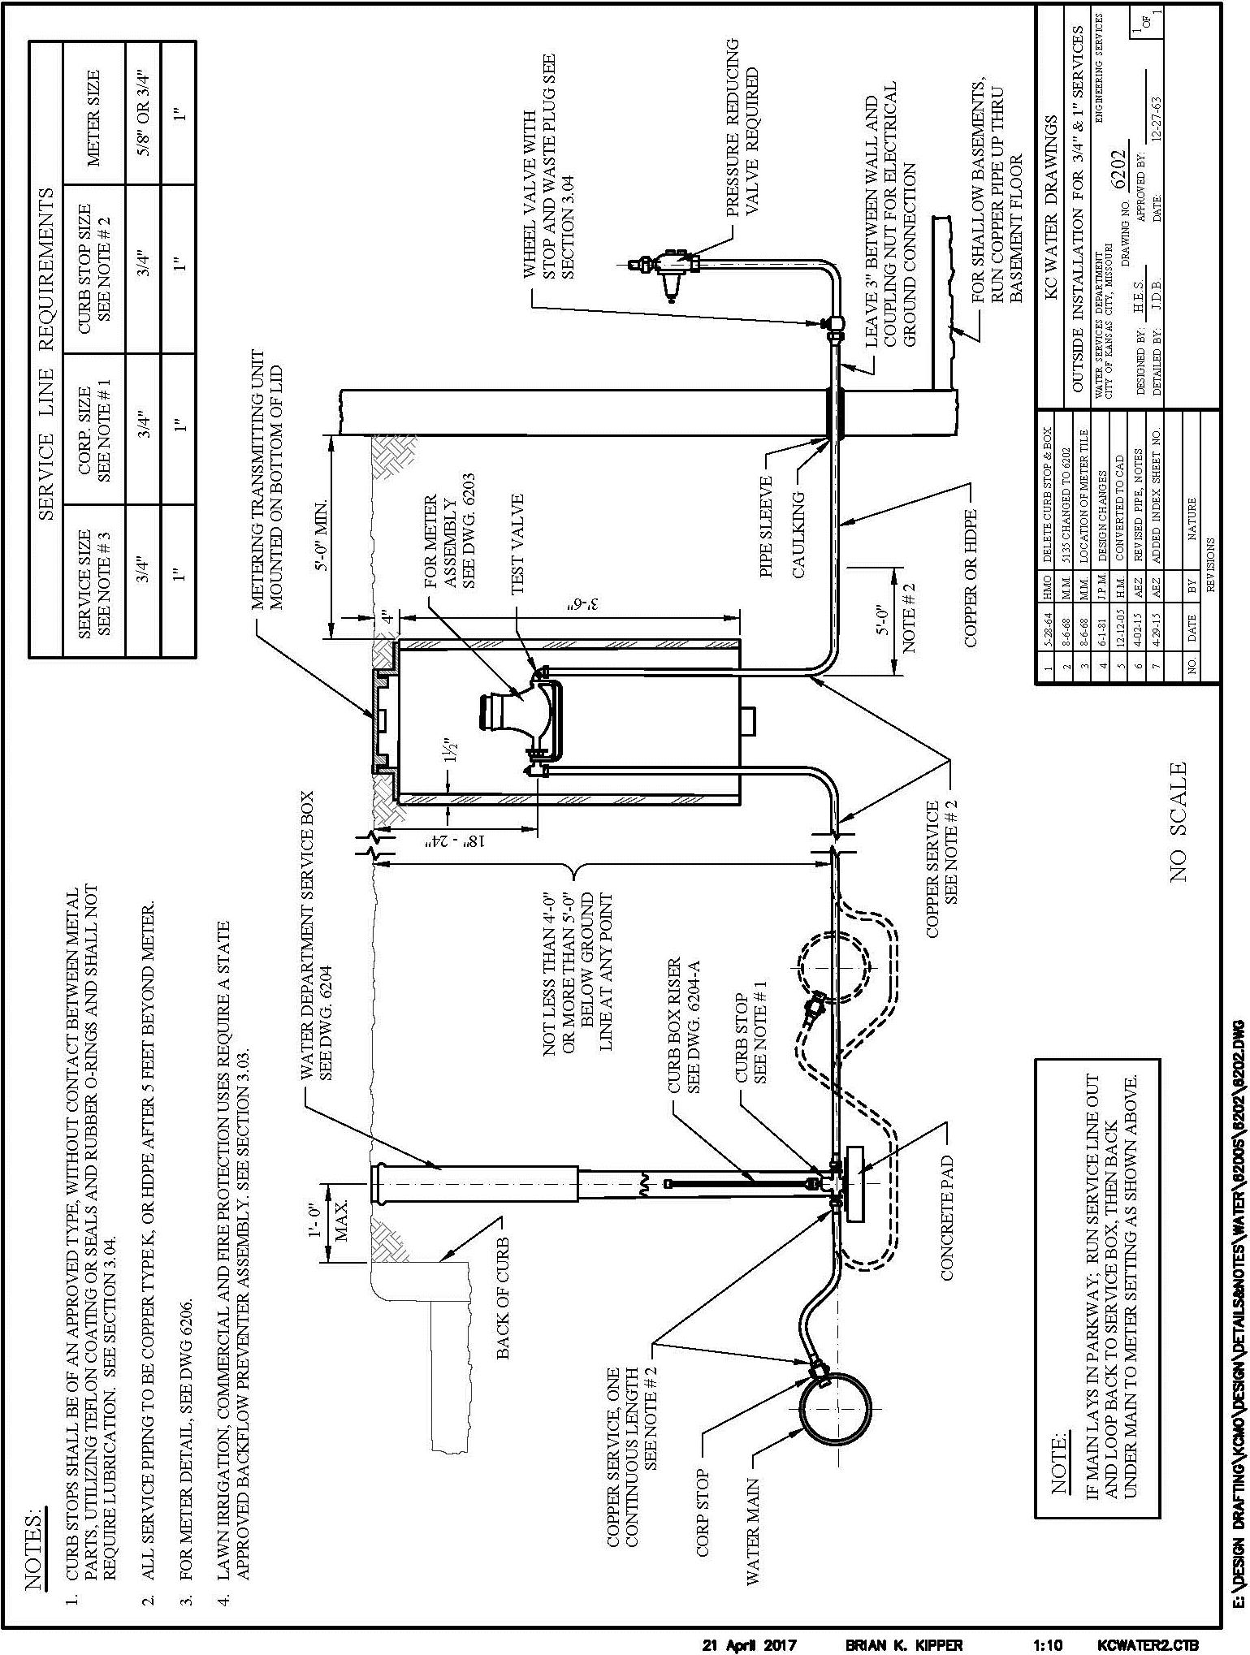
6202 Outside Installation for 3/4" and 1" Services

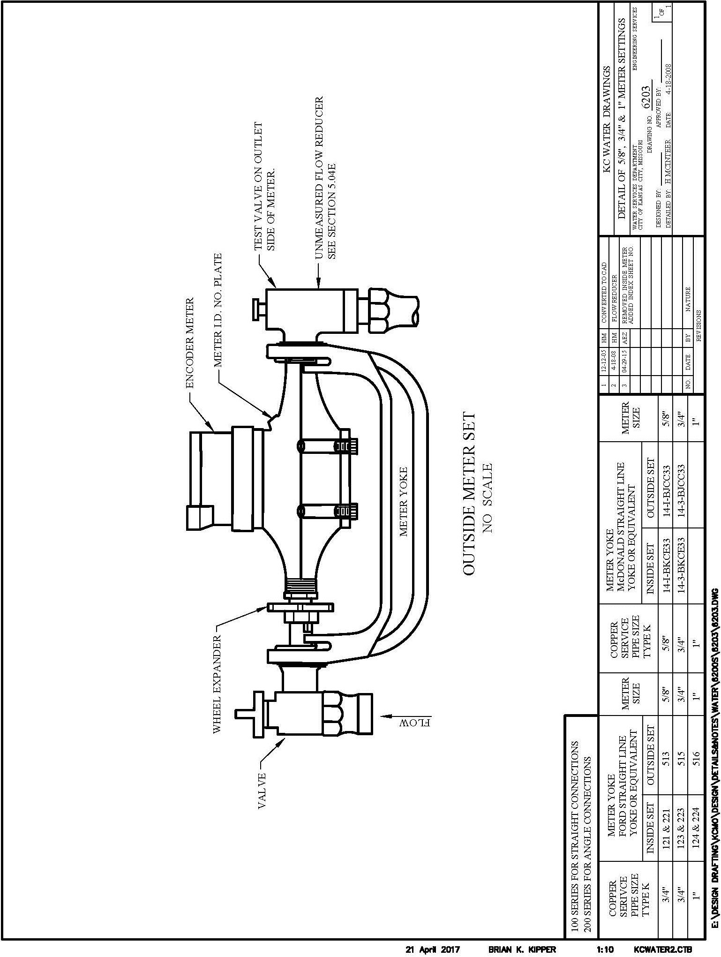
6203 Detail of 5/8", 3/4" and 1" Meter Settings

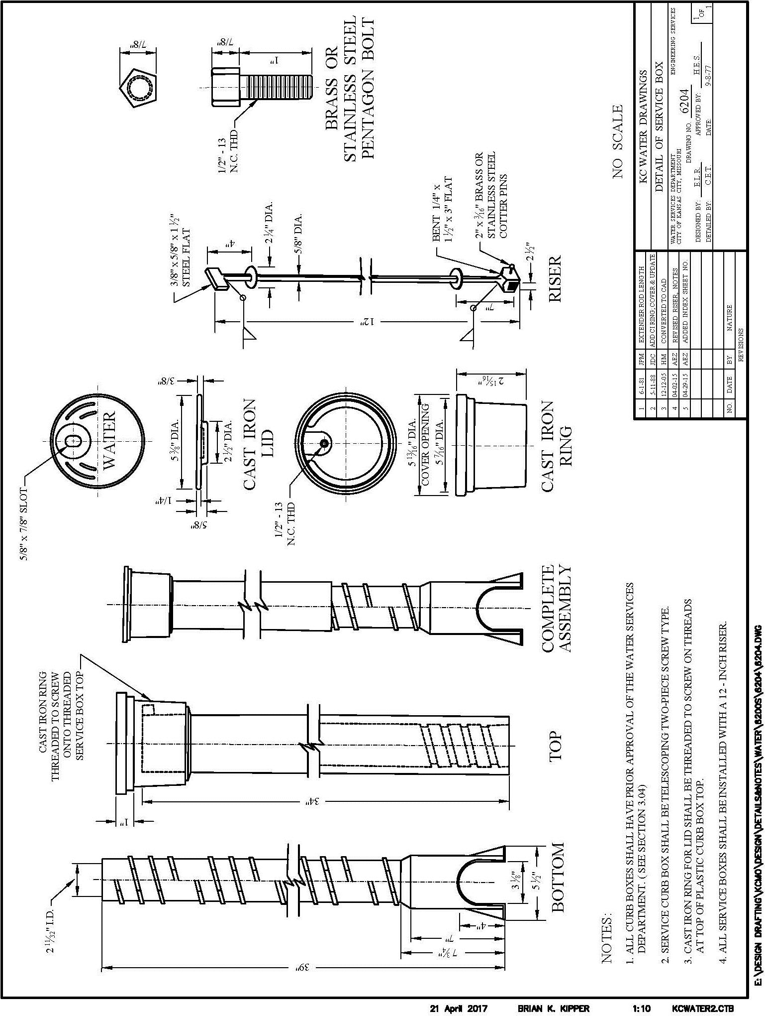
6204 Detail of Service Box (Curb Box)

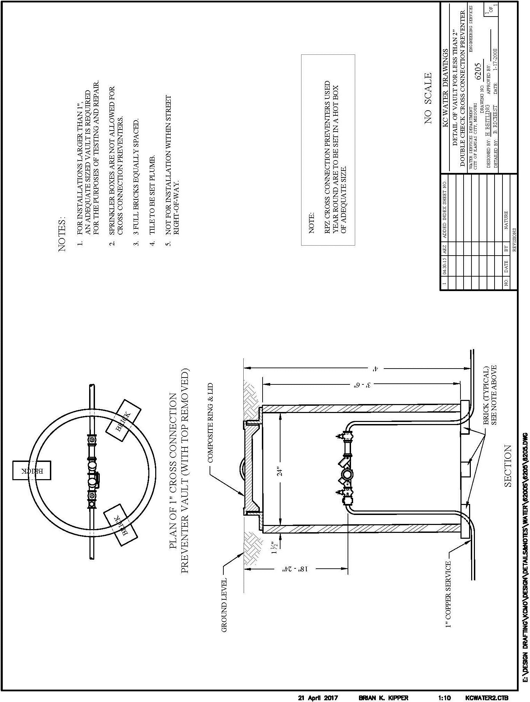
6205 Detail of Vault for Less than 2" Backflow Preventer

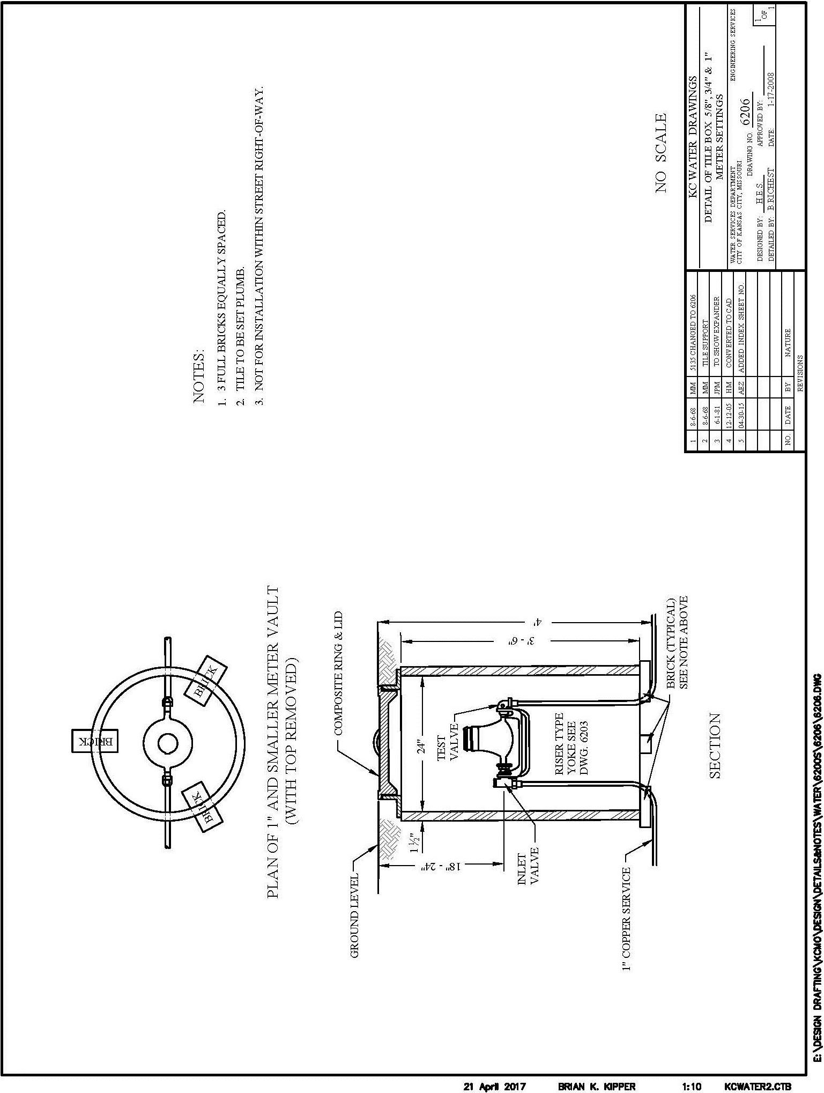
6206 Detail of Tile Box for 5/8", 3/4" and 1" Meter Settings

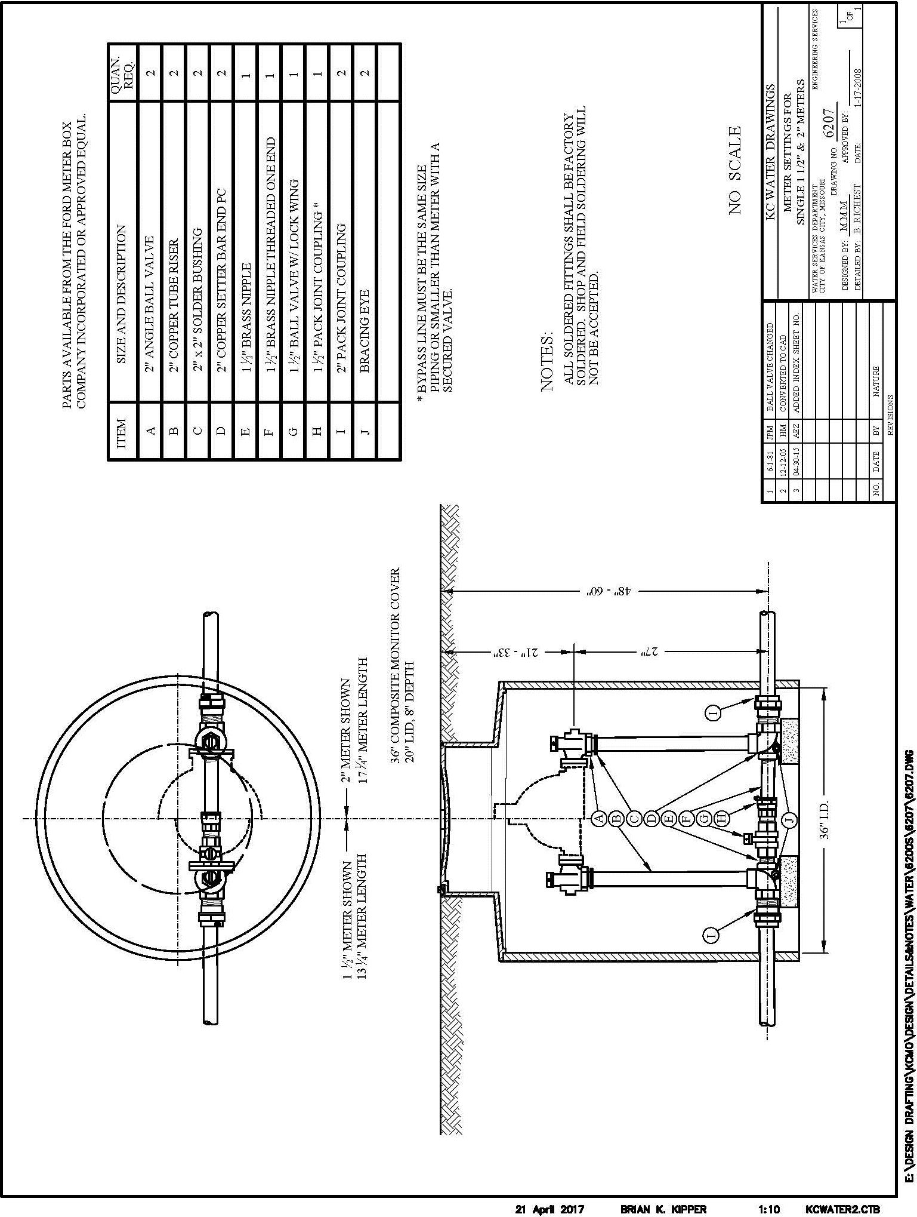
6207 Water Meter Settings for Single 1-1/2" and 2" Meters Settings

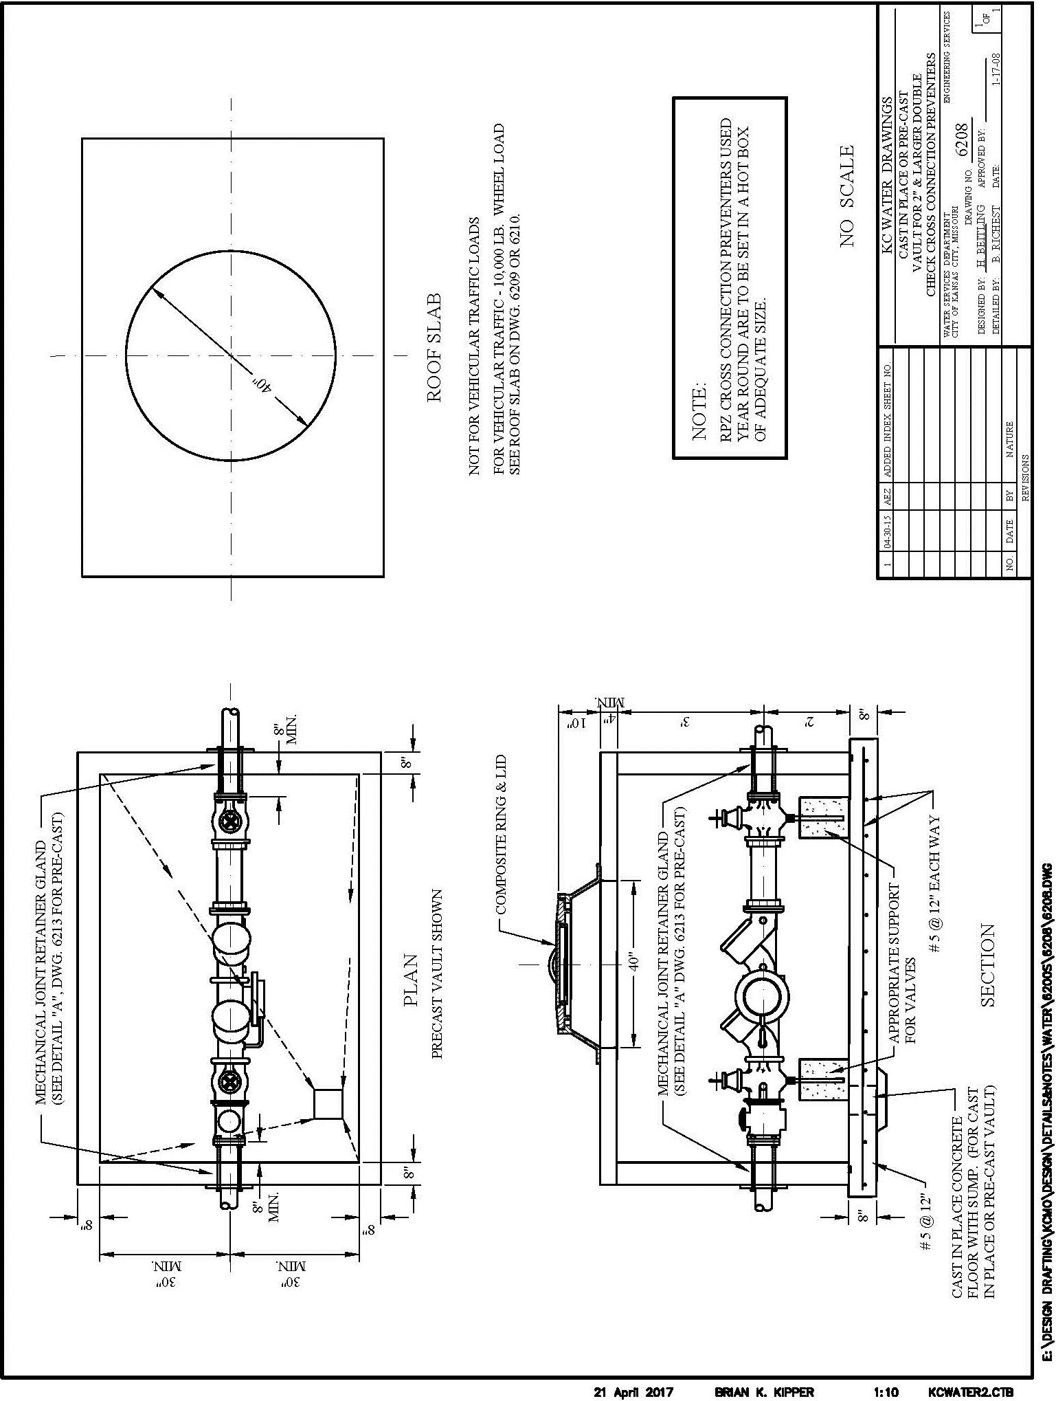
6208 Cast-in-Place or Pre-cast Vault for 2" & Larger Backflow Preventers

6209 Cast-in-Place or Pre-cast Meter Pit & Setting with Bypass for Single 3" through 10" Meters
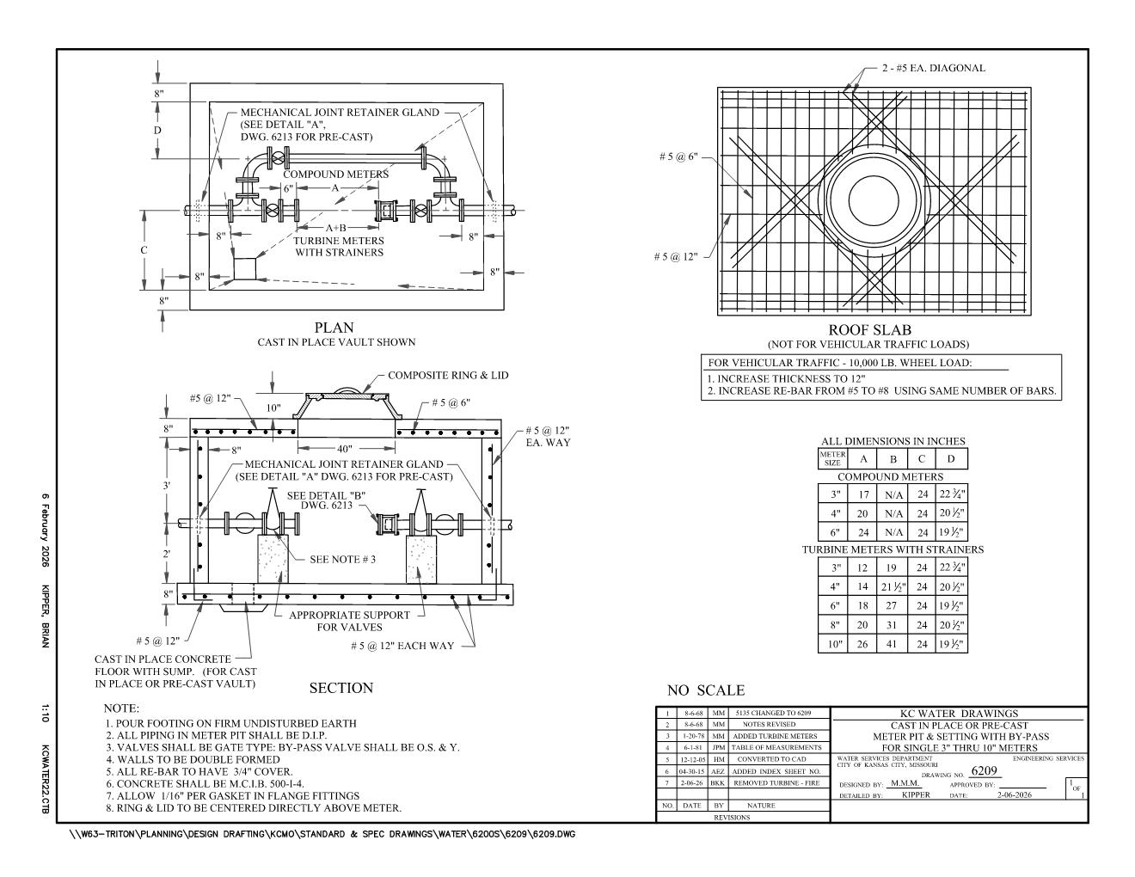

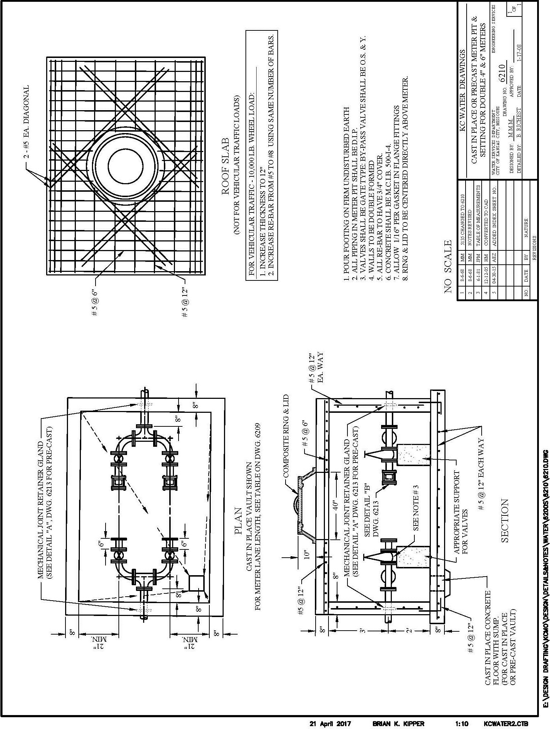
6210 Cast-in-Place or Pre-cast Meter Pit & Setting for Double 4" and 6" Meters

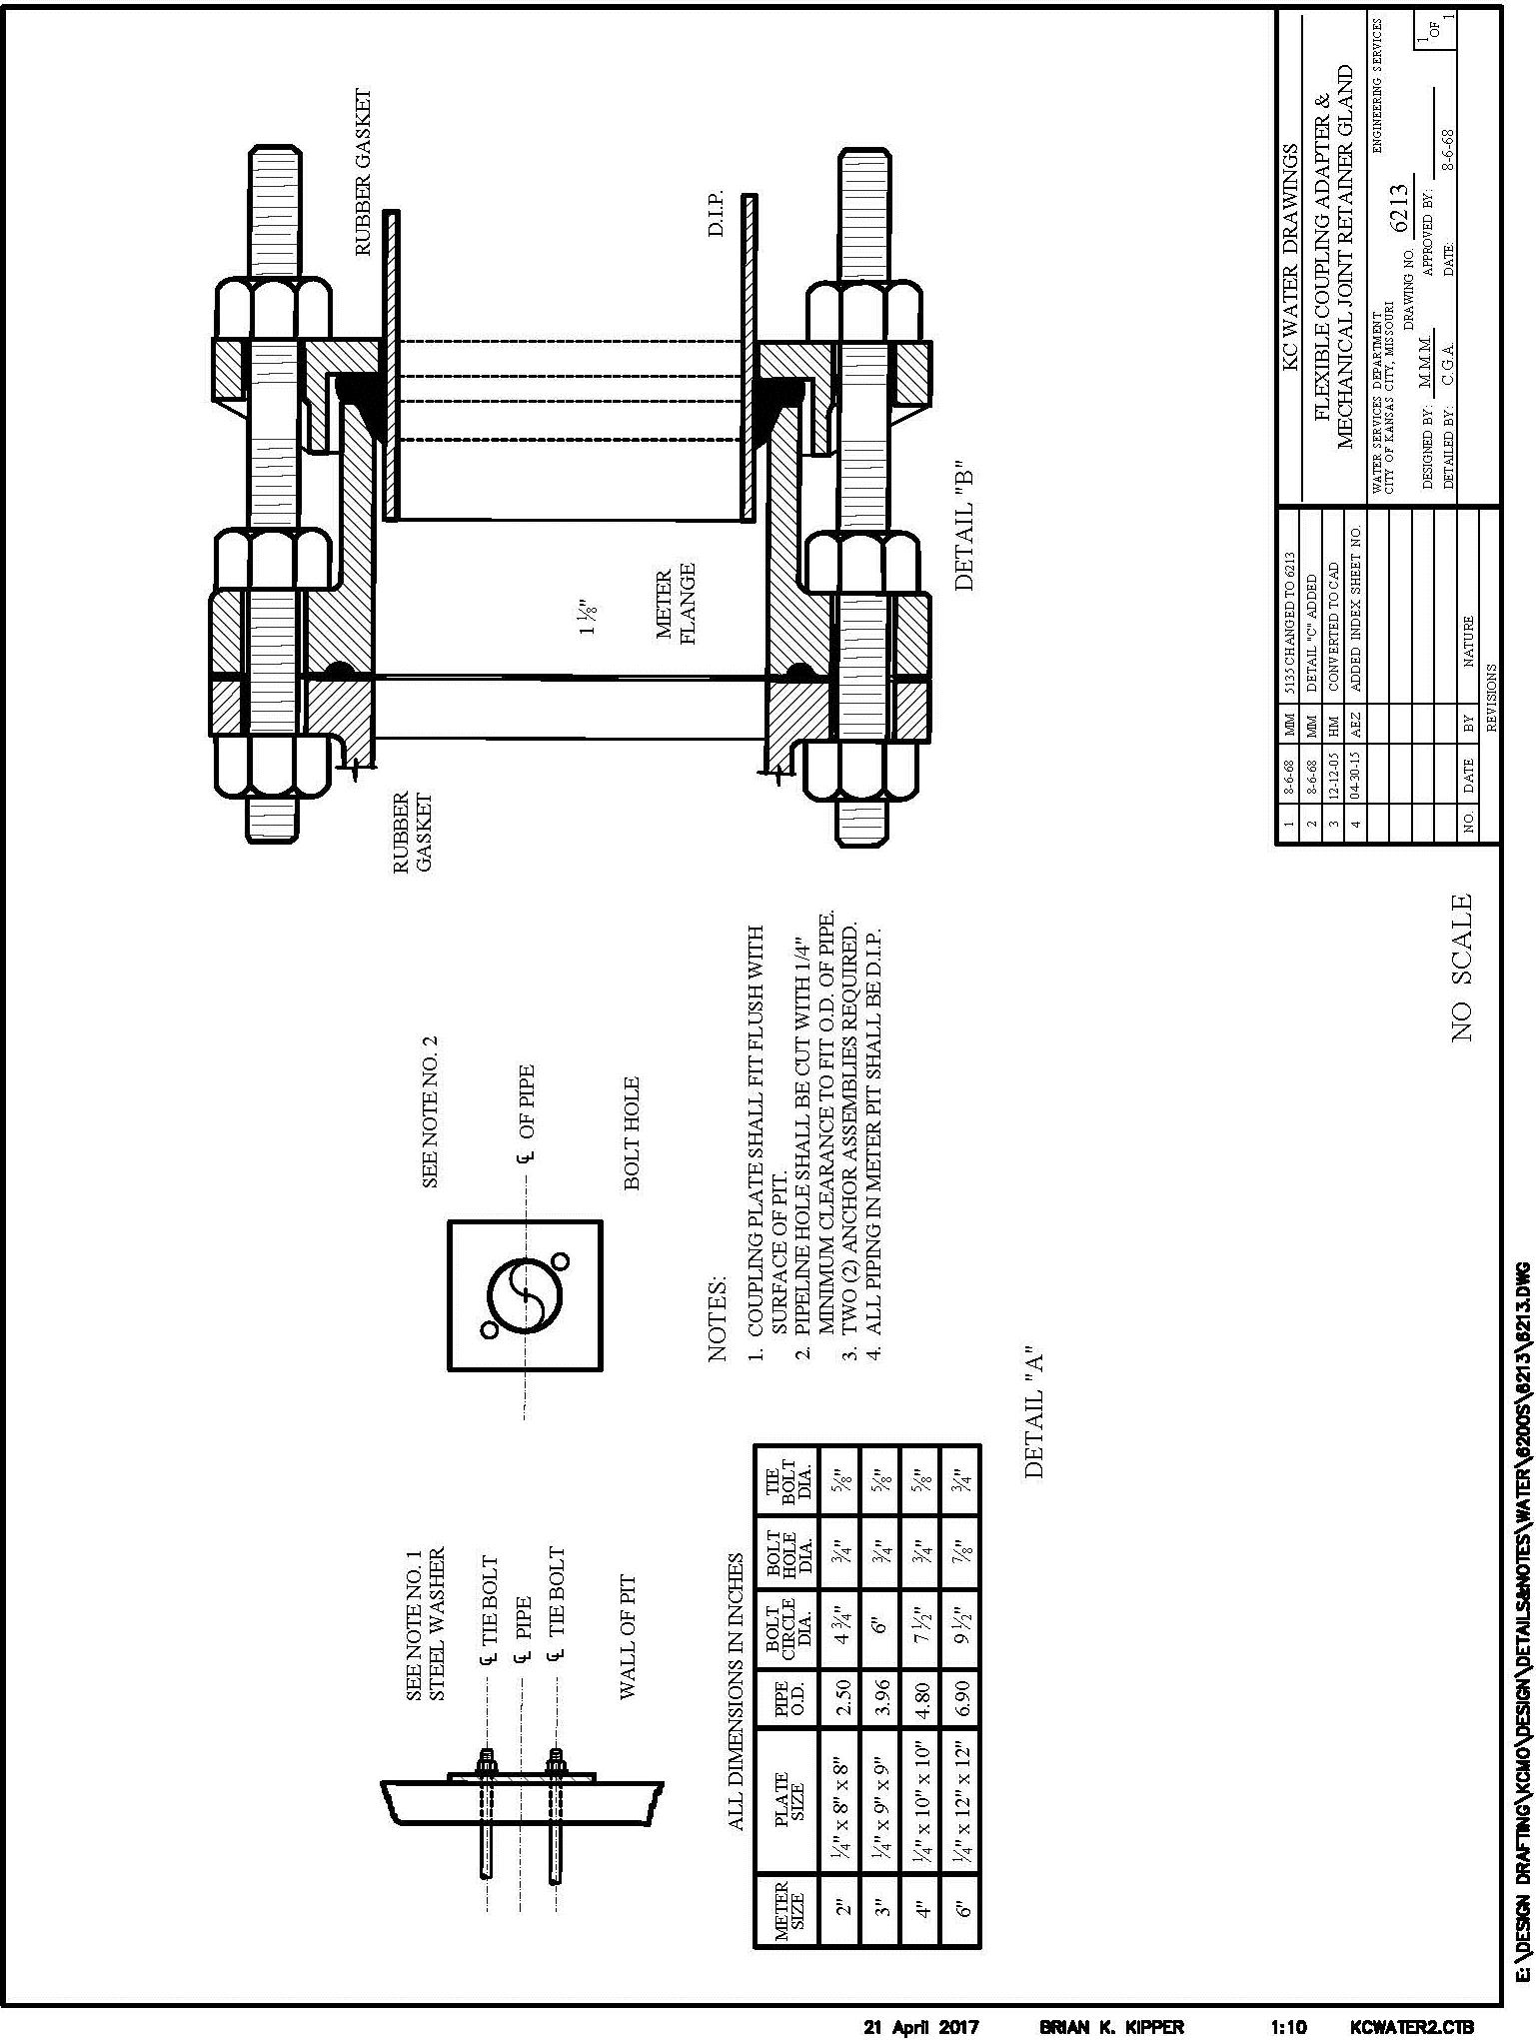
6213 Flexible Coupling Adapter & Mechanical Joint Retainer Gland

6214 Combination Service Lines

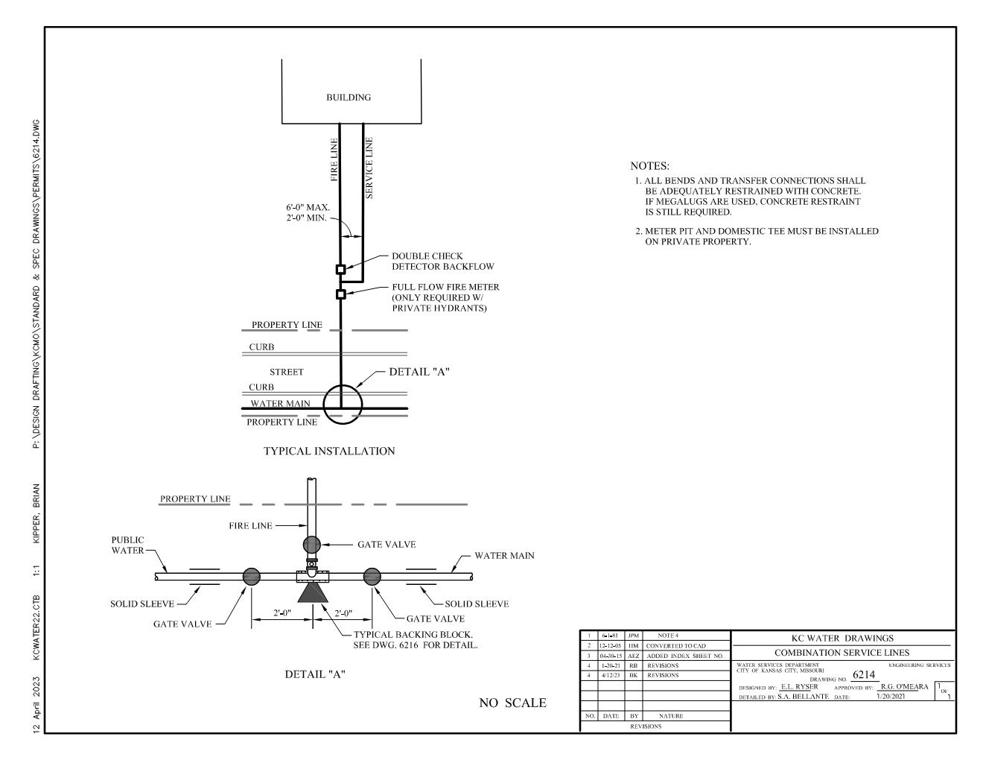

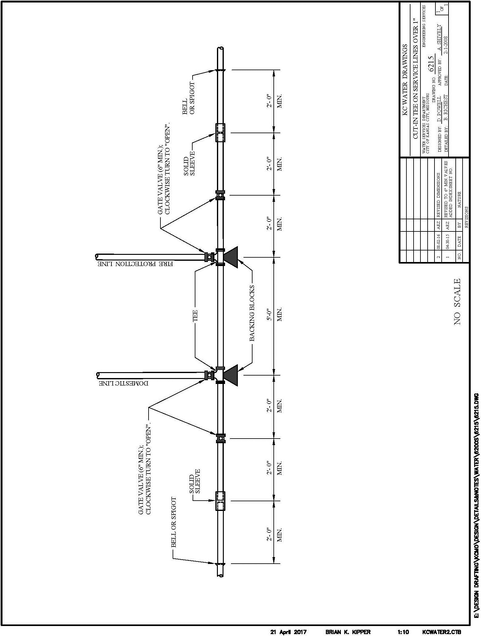
6215 Cut In Tees on Service Lines

6216 Excavation Details for Corporation Taps

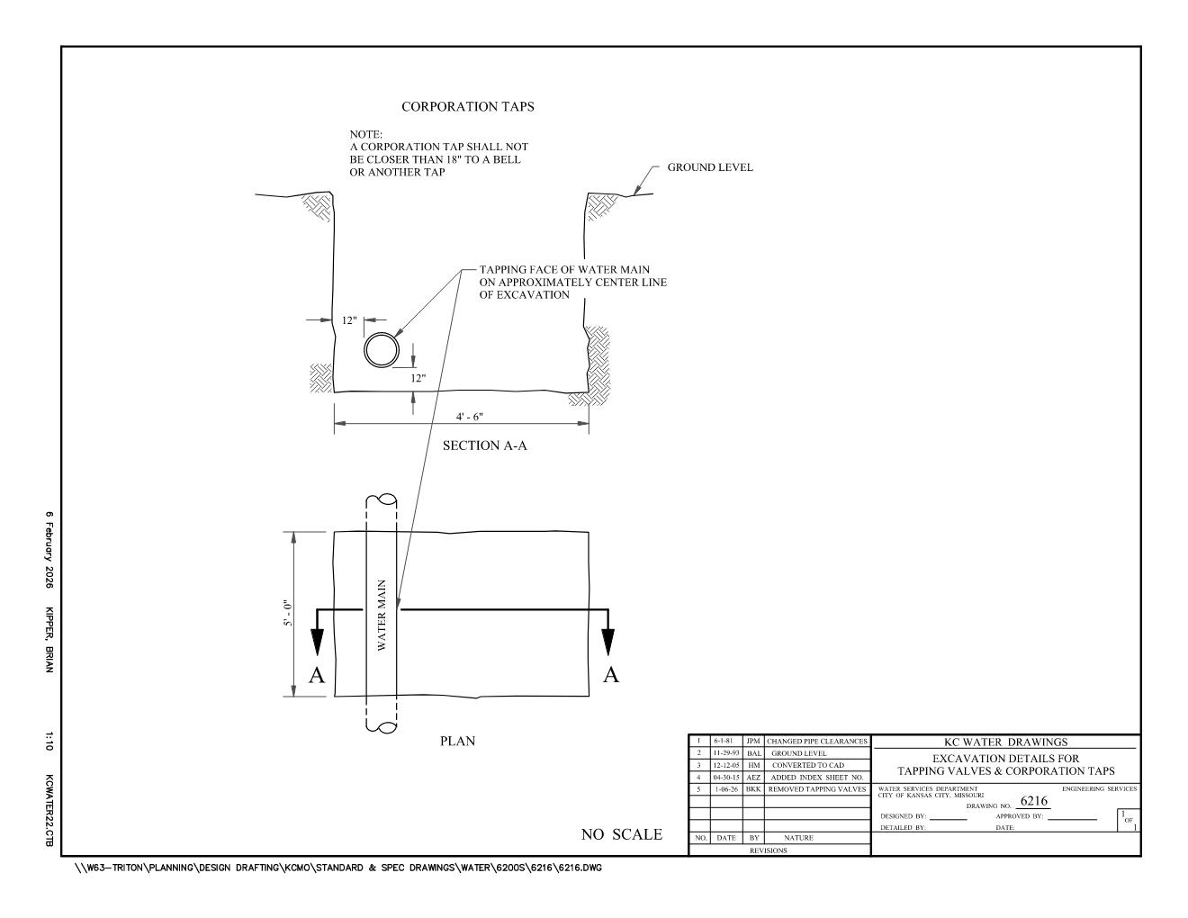
6217 Cast-in-Place or Pre-cast Meter Pit & Setting with Bypass for 6" Through 10" Meters

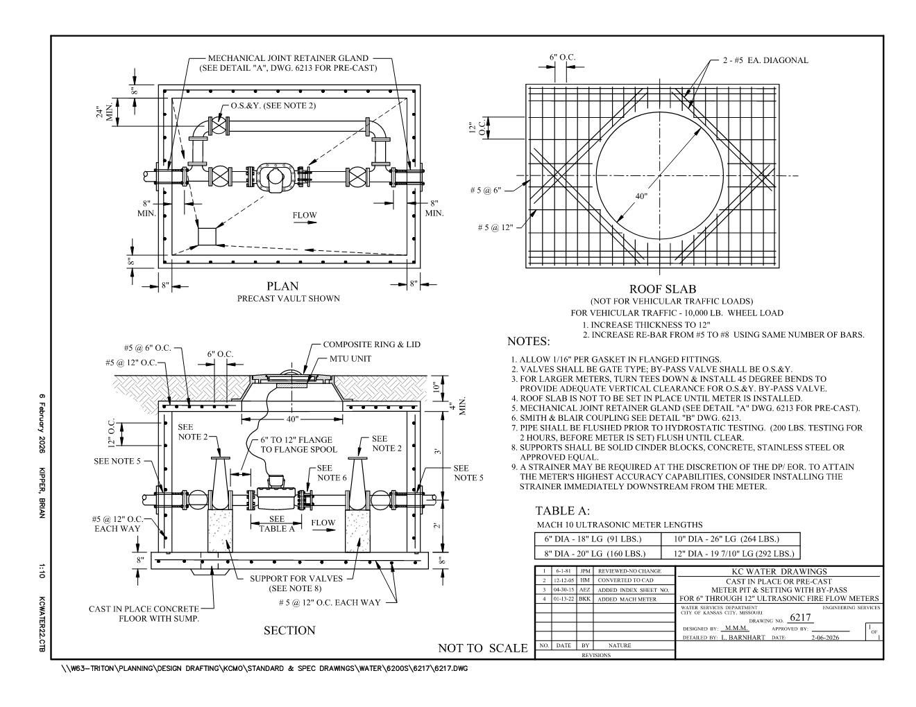
6218 RPZ BACKFLOW DETAIL
