KC Water
Rules and Regulations For Sewer Service Lines



May 2026

Introduction

These regulations are established to provide for an orderly growth of the City's sewer system and to assure equitable treatment to all citizens. All those who have transactions with KC Water are urged to observe these regulations and to cooperate in their enforcement. Chapters 60 and 61 respectively, of the Kansas City, Missouri Code of Ordinances, grants the Director the authority to make and enforce these regulations.
Sewer service lines and related appurtenances shall meet all currently adopted City of Kansas City, Missouri Building Codes, International Plumbing Code 2024, APWA 2500, APWA 2600, APWA 5500, APWA 5600, Code of Ordinances Chapters 60 and 61, as well as these rules and regulations.
These are generally permissive regulations. This means that rather than including an endless list of prohibitions, the regulations are kept simpler by stating what is allowed. Sewer service lines and connections to the main shall only be installed in accordance with these regulations, and only by methods, and at times and under the circumstances described in these regulations. Installations or arrangements other than those described in these regulations are not allowed. KC Water anticipates that these regulations will be updated on an annual basis; however, they may be revised sooner if deemed necessary by KC Water.

Table of Contents

SECTION 1.00 – PERMITS 5
  - Property Owner Accounts 5
  - Definition of Permits 5
  - Classification of Permits 5
  - No Work Prior to Permit Issuance 5
  - Plumbers Not to Secure Permits for Others 6
  - Permits Not Transferable 6
  - Expiration of Permits 6
  - Permit Fees 6
  - Delinquent Permits 6
  - Issuance of Permits 7
  - Qualifications of Applicants 7
  - Required Conditions 7
  - Required Procedure 7
  - Applicants's Responsibility 8
  - Permit Cancellation 8
  - As Built Drawings 8
SECTION 2.00 - SEWER MAINS 9
  - Definition 9
  - Classification of Mains 9
  - Connections to Sewer Mains 10
  - Paralleling of Mains 10
  - Operation of Public Mains 10
SECTION 3.00 - SEWER SERVICES 11
  - Definition 11
  - Materials 11
  - General Installation Requirements 12
  - Installation Requirements for Sewer Service Lines to Gravity Mains 12
  - Installation Requirements for Pressurized Sewer Service Lines to Mains 14
  - Maintenance of Services 14
  - Abandonment of Services 14
  - Reconnection of Services 14
  - Water Service Lines crossing or near KC Streetcar 14
SECTION 4.00 – INSPECTION 16
  - Sewer Service Lines Inspection Requirements 16
  - Definition of Inspection 16
  - When Required 16
  - Scope of Inspection 16
  - Time of Inspections 16
  - Request for Inspection 16
  - Conditions for Inspection 16
4.08 Inspection by Registered Professional Engineer 17
APPENDIX 18
Figure 3.1 19
Figure 3.2 20
Figure 3.3 21
Figure 3.4 22
Figure 3.5 23
Figure 3.6 24
Figure 3.7 25

SECTION 1.00 – PERMITS

  - Property Owner Accounts No permit shall be issued to a licensed master plumber on behalf of an owner unless all accounts are current and paid in full.

  - Definition of Permits A Water Service Permit is a written document issued by KC Water authorizing work to be performed. The purpose of these permits is to insure order in the growth of the sewer system and that only qualified persons engage in this work. The Director is authorized to require permits for service connections and under Chapters 60 and 61 respectively, of the Kansas City, Missouri Code of Ordinances.

  - Classification of Permits Permits are of five (5) kinds, defined as follows:

- New Service Permits are required where new connections to a sewer main are to be made, and new services are to be installed. New service for Commercial and Residential service(s) shall include connection service stubs installed during construction of the main and cutting in wyes or tees on the sewer main.


- Repair Permits are required where an existing service is to be altered, extended, repaired or renewed, by a licensed plumber for an occupant or property owner, from the main to one foot inside the property line, outside the right-of-way or easement. Residential and Commercial service(s) shall include proper connections on the sewer main for all existing service lines. All sewer service lines repairs and related appurtenances shall meet the most current version of KC Water Rules and Regulations.

- Backflow Permits are required on all new and existing residential, commercial, industrial, sewer service lines which are required to have approved backflow prevention assemblies installed in the service line for connection to pressurized or surcharged mains.

- ​ Kill Permits are required where an existing service that is to be abandoned, relocated, or disconnected is connected to a public main. The service that is to be abandoned or relocated shall be cut and capped at the sewer main. Service lines that are disconnected for demolition and to be reused for a permitted building shall be cut and capped at five (5) foot inside the property line, outside the right-of-way or easement, in a manner determined by KC Water.

- Renewal of Expired Permits is required when the work has not been completed and inspected on the water line at the expiration of the original permit (180 Days).

Sewer connection and inspection fees shall be set annually by the Director as authorized under Chapter 60 and 61 respectively, of the Kansas City, Missouri Code of Ordinances.
  - No Work Prior to Permit Issuance No work associated with the connection to any sewer main nor shall any sewer service line be altered, repaired, replaced, or extended without prior issuance of a permit authorizing the performance of such work. Any work that has been started or completed without first obtaining a permit for such work, shall have the fee specified for such permit tripled. Connecting to a sewer main without the sewer main being released for connections

or without obtaining a permit and paying the connection fees for such work, shall have the permit and connection fees specified tripled. When the plumber must perform emergency work during other than normal working hours, KC Water (Emergency Dispatch) shall be notified by telephone at 816-513-1313 prior to the starting of such work and the plumber shall secure the permit on the next regular working day. This provision shall not be construed as permission to begin work without the required permits. Inspection to be performed during other than normal working hours.
  - Plumbers Not to Secure Permits for Others A Master Plumber's or Journeyman Plumber's license is not transferable, and any Master Plumber shall subject himself to suspension if he attempts or procures a permit for the benefit of anyone other than himself. The Master Plumber is responsible for all work done that is described under the permit issued.

  - Permits Not Transferable Permits are not transferable and are only valid for the applicant to whom issued and for the job described thereon.

  - Expiration of Permits When a permit is issued, the permit will be valid for one hundred eighty (180) consecutive days. If the work has not been completed on the service line at the expiration of the permit, the permit can be renewed for an additional one hundred eighty (180) days by making a request in writing to the KC Water permit desk. If the work has not been completed after one (1) year of issuance of the permit, a new permit will be required. Any work abandoned during the one hundred eighty (180) day period or during the extended period will require a new permit before commencing at one-half the fee of the original permit. Permit fees for expired permits will not be refunded.

  - Permit Fees All permit fees, plan review fees, charges for connections to sewer mains, meters, and meter setting will be paid by the applicant at the time of procuring the permit.
    - Permit fees, sewer connections inspection fees, and plan review fees shall be published by KC Water and are authorized by the Director under Chapters 60 and 61 respectively, of the Kansas City, Missouri Code of Ordinances, and shall not be refundable.
    - Current Sewer Service Connection/Inspection Fee is $142.

  - Delinquent Permits No permits will be issued to anyone who is holding a delinquent permit. A permit will be considered delinquent when any of the following criteria are met:

- Failure to rectify a rejection on inspections including final inspections occurring within one year of permit issuance, subsequent the completion of work by the plumber.

- No permit shall be issued to a licensed master plumber that owes any fees or for a property where monies are owed to KC Water until all accounts and fees are paid in full.

- Any unpaid job orders or other amounts owed to KC Water.

- Failure to return permit with required accurate as-built drawings two weeks after work is completed.

  - Issuance of Permits KC Water shall issue Permits to qualified applicants only after all the requirements are satisfied. Permits are issued subject to a sewer main being directly opposite the building to be served. No service line shall be located in a lot other than the lot that is the site of the building or structure served. Failure of the applicant or the property owner to pay a bill for services rendered by the City shall be a basis for denial of further permits until such bill or bills is paid. Persistent violation of the provision may be considered cause for revoking the Master Plumber's license held by the offender. Property owners who fail to pay all applicable monthly charges and fees on their accounts for water or sewer services to the property(s) may be cause for the sewer services to be disconnected at the discretion of KC Water.

  - Qualifications of Applicants Applicants shall be prepared to show proof of qualification at the time of application and shall procure permits for themselves and no other. Permits shall be issued only to the following:

- A Master Plumber who may apply as a firm, partnership, or corporation. The term "Master Plumber" as used herein shall be as defined in the Building Code.

- Other water utilities or municipalities that purchase sewer service from the City.

- Contractors who are performing work under City contract that required them to modify existing sewer facilities may be issued permits for the work defined in the contract.

- Licensed Wrecking / Demolition Contractors may be issued kill permits for disconnecting service lines up to and including 6” service lines only. Larger service lines shall be disconnected from the sewer main by a Licensed Master Plumber.

  - Required Conditions Prior to receiving the permit, the applicant must perform the following:

- Complete application and billing information in compasskc or at the KC Water permit desk. Plans signed and sealed by a registered professional engineer, licensed in the State of Missouri, are required for commercial connection applications.
- Obtain an excavation permit from Public Works, when required.
- Pay for permit and obtain receipt.
  - Required Procedure Each application for a permit shall be made in writing and shall be signed by the applicant, as defined in Section 1.10, or their duly authorized agent for the licensed master plumber; it shall state in precise terms the work to be done under the permit. In addition, each application shall contain the following information:

- The name of the person for whom the work is to be performed or the owner of the property served.

- The correct address and other legal description where work is to be performed. House numbers must be assigned as approved by the City Planning and Development Department on the building permit. Building permit must also be available, where applicable.

  - Applicant's Responsibility An applicant shall be responsible for any damage, defective workmanship performed, or material furnished for a period of one year from the date of the last approved inspection. The applicant is defined in section 1.10. An agent for an applicant shall not be construed as the applicant for purposes of this section.

  - Permit Cancellation When an applicant is holding a permit in which no work will be done, the applicant must cancel the permit. This will be accomplished by giving notice to KC Water by phone, fax, e-mail or U. S. mail. Cancelled permits shall not be refundable. The Director of KC Water shall be authorized to cancel for cause any permit issued.

  - As Built Drawings Two weeks after work is completed on any permit, that permit shall be returned to the Permit Desk with an accurate drawing showing dimensions and locations of all work performed. These drawings may be verified for accuracy by KC Water. Failure to do so will result in the permit being considered a delinquent permit. Future permits shall not be issued to an applicant that is holding a delinquent permit. See section 1.08

End of Section

SECTION 2.00 - SEWER MAINS
  - Definition A sewer main is the pipe, fittings, valves, boxes, and appurtenances installed as an integral part of the trunk system, but not including sewer service lines.

  - Classification of Mains Sewer Mains are classified functionally as Trunk Mains, Interceptor Mains. A further classification is also made into Sanitary, Storm, or Combined Sewers, Gravity or Force Mains as well as Public Mains and Private Mains. These mains are further described as follows:
- A Trunk Main is a sewer line that receives wastewater or storm water from many tributary branches and sewer lines and serves as an outlet for development or is used to feed an intercepting sewer. It is the principal means of providing sewer coverage for customers through a service line connection. These mains are normally twelve (15) inches and smaller in diameter, or as determined by KC Water.

- An Interceptor Main is a major sewer line that receives flows from trunk sewer lines. This flow is then directed to a wastewater treatment facility. These mains are normally eighteen (18) inches in diameter and larger, or as determined by KC Water.
- A Sanitary Sewer carries sewage through underground pipes to a wastewater treatment plant. Sanitary sewers originate from bathrooms, sinks, kitchens, and other plumbing sources.

- A Storm Sewer is a system designed to carry precipitation runoff and untreated water. They are not designed to carry sewage or accept hazardous wastes. They can often be found, built into roadside curbs, alleys, or parking lots. Storm sewers carry precipitation runoff and untreated water through open channels and underground systems that ends up in nearby rivers, creeks, ponds, or the lakes.
- A Combined Sewer is a sewage collection system of pipes, tunnels, channels, and bodies of water designed to simultaneously collect surface runoff and sewage water in a shared system.
- Gravity Mains are a conduit utilizing the energy resulting from a difference in elevation to remove wastewater or storm water.

- Force Mains are conduits that convey wastewater under pressure from the discharge side of a pump or pneumatic ejector to a discharge point. Pumps or compressors located in a lift station provide the energy for wastewater conveyance in force mains.

- A Public Main is a sewer main that serves more than one property, that is owned and maintained by the City, and is located in a public easement or right-of-way.

- A Private Main is a sewer main that serves more than one property, that is owned and maintained by a private entity. These are also known as Community Sewers. Private Mains shall be located in a private easement or an identified maintenance area. This document shall be attached as an exhibit to a covenant to maintain private sewers to address the perpetual care,

maintenance, and repair of the private sewer. The covenant to maintain private sewers shall be recorder with the County Recorder of Deeds and shall run with the land. A private sewer shall not be construed as a sewer service line, lateral, or building drain.

  - Connections to Sewer Mains Sewer service connections to Interceptor Mains are not permitted without prior approval from KC Water. Connections to mains shall be made as provided in these rules and regulations, "Section 3.00, Sewer Services."

  - Paralleling of Mains When a new Public Main is laid paralleling an obsolete existing main, connection between the new Public Main and existing individual services will be made at the expense of the party causing the work to be performed, as determined by KC Water, and the obsolete main will be abandoned. This work will include any necessary extension or abandonment of existing services in accordance with these rules and regulations.

  - Operation of Public Mains Operation of sewer mains and other appurtenances shall be performed only by KC Water Personnel. Requests by plumbers for the shutting down and/or bypassing of mains shall be made at a reasonable time in advance, and shutdown and/or bypass will normally be performed during regular working hours or at the discretion of KC Water unless a request stipulates otherwise. When shutdowns and/or bypasses are made for the benefit of the person making the request, they will be charged for this service on the basis of the prevailing labor and equipment rates, as determined by KC Water.

End of Section

SECTION 3.00 - SEWER SERVICES
  - Definition A Sewer Service line is the piping and appurtenances installed from the sewer main to that portion of the interior piping that is regulated by the Building Code. Where there are differences in the requirements set forth for the service lines and connections to the main in these rules and regulations and the Uniform Plumbing Code, these rules and regulations shall prevail.

Materials
    - Pipe:
      - Approved gravity service line pipe materials are: polyvinyl chloride (PVC) or ductile iron pipe (DIP).
      - Pipe materials other than those listed above shall not be used for sanitary sewer service laterals unless otherwise approved by the City.
      - General requirements:
        - No gravity sewer service line shall be constructed with an inside diameter of less than four (4) inches.
        - Ductile Iron Pipe (DIP) shall conform to the same specifications as Ductile Iron Pipe for Sewers.
        - Polyvinyl Chloride (PVC) pipe shall conform to the same specifications as Polyvinyl Chloride (PVC) Gravity Sewer Pipe.
    - Fittings:
- All fittings shall be factory-produced and shall be designed for installation on the pipe to be used. Fittings shall be of the same quality and material as the pipe used.
- Saddles for Tapping the Public Sewer:
  - VCP sewer main: a plastic (PVC) strap on saddle with a neoprene gasket under the saddle shall be used.
  - PVC sewer main: a plastic (PVC) strap on saddle with a neoprene gasket under the saddle shall be used.
  - DIP sewer main: a plastic (PVC) strap on saddle with a neoprene gasket under the saddle shall be used.
  - RCP sewer main: a plastic (PVC) strap on saddle with a neoprene gasket under the saddle shall be used.
- Inserta Tee or approved equivalent may be used for connection to mains 18” and larger for the following main pipe materials:
  - VCP
  - PVC
  - RCP
  - DIP
  - HPDE
- Couplings for point repairs:
  - All couplings shall form tight compression joints.
  - When connecting to the existing sanitary sewer service line, the Contractor shall use Non-Shear Fernco Strongback 5000 series couplings, MaxAdaptor couplings or City approved equal.

General Installation Requirements

    - All work shall be performed in accordance with applicable OSHA standards. Owner area of responsibility is depicted on Figure 3.1.

    - Applicant shall clear the work area required for excavation in accordance with adopted standards. It is the applicant’s responsibility to provide a photo or video log of the work zone(s) and to protect and restore the area to a condition as good as or better than it was before the Work was started. All removed fences; shrubbery, sidewalks, planters and landscaping shall be restored utilizing new materials unless otherwise directed in writing by both the Owner/Occupant and the City.
    - Existing Utilities:
      - The applicant is responsible for protecting all utilities. All permits and licenses required for the execution of the Work shall be obtained by the applicant.
      - The applicant shall notify all utilities at least 48 hours in advance before making excavation in accordance with Missouri State Law.
      - When water mains or water service lines exist in the area, the applicant shall comply with all applicable rules and regulations of the Kansas City, Missouri Water Services Department and the Missouri State Board of Health.
    - At no time shall wastewater be discharged on streets, alleys, or in storm drainage systems. The applicant shall provide adequate temporary by-pass pumping for routing the flow of wastewater around the section of pipe under repair.
    - The applicant shall take all necessary steps to prevent the flooding of any resident or business and shall be liable for any damages incurred by basement backups.

Installation Requirements for Sewer Service Lines to Gravity Mains
    - Construction:
      - The maximum turn permissible at any one fitting shall be forty-five
(45) degrees (one-eighth (⅛) bend). Min. 30 Degrees & Max. 60 Degrees as shown in Figure 3.2.
      - Sewer service lines shall be connected to a tee, wye or a manhole on the public sewer when such is available. Where no tee, wye or manhole is available, the sewers shall be tapped. Section 3.02 lists the type of saddles permissible depending on the material of the sewer to be tapped.
      - Repairs on a sewer service lines within the right-of-way or easement shall be done in accordance with Figure 3.3 and as described herein.
      - Replacement of a sewer service line connection shall be done in accordance with Figure 3.4 and as described herein.
      - Sewer service lines connected to cured in place pipe (CIPP) lined mains shall be done in accordance with Figure 3.5 and as described herein.
      - Sewer service lines connected to brick mains shall be done in accordance with Figure 3.6 and as described herein.
      - Sewer service lines connected to any sewer structures other than mains must obtain a major infrastructure permit from KC Water for the connection of the private sanitary sewer service to the public sanitary manhole. The type of review that will be created will be CLDPIR-20XX-00XXX which is for the public infrastructure review.

    - Excavation:
      - Excavation required for sanitary sewer service lines shall be done in accordance with adopted standards.
      - Width of Trench: The width of trench at the top of a pipe shall not exceed the outside diameter of the pipe plus eighteen (18) inches.
      - Boring/Tunneling:
        - Boring/Tunneling will be permitted only under existing utilities or upon permission from KC Water.
        - If boring/tunneling is permitted, the applicant shall submit to KC Water for approval the method of boring/tunneling, type of bracing and precautions used to prevent a collapse.
      - Sheeting, Shoring and Bracing: The applicant shall do all necessary trench bracing, shoring, or sheeting to prevent slides or cave-ins. Additional shoring, sheeting, and bracing shall be placed wherever required, as determined by KC Water, for the successful and safe prosecution of the work.
    - Pipe Embedment:
      - The granular embedment for sewer service lines shall be placed in accordance with adopted standards.
      - The sewer trench in earth excavation shall be carried to a point not less than four (4) inches below bottom of the pipe barrel and in rock excavation to a point not less than six (6) inches below bottom of pipe barrel.
      - Installation:
        - The pipe bedding shall be compacted to the bottom of pipe with proper allowance for bell joints. After each joint of pipe has been properly seated and placed in proper alignment, pipe embedment shall be placed and compacted to a minimum of twelve (12) inches above the pipe bell. In no case shall brick or other large stones be used as bedding.
    - Line and Grade: Minimum Grade: The minimum grade allowable for private sewer laterals in public right-of-way will be one-fourth (¼) inch per linear foot or 2% toward the point of disposal. Where it is impractical due to depth of the sewer, to the structural features, or to the arrangement of the building to obtain a slope of (1/4) inch per linear foot or 2%, such pipe or piping 4 inches or larger shall be permitted to have a slope of not less than (1/8) inch per linear foot or 1%. In no case will a sewer service line in public right-of- ways or easements be constructed having a grade less than one-eighth (⅛) inch per linear foot or 1%.
    - Minimum Allowable Cover: A minimum cover of four (4) feet from top of pipe to the finish grade of ground surface is required for all sanitary sewer service lines in public rights-of-way or easements under the control of the City for sewer purposes.
    - Backfill:
      - Backfill shall be made in accordance with adopted standards.
        - Bedding material shall be placed a minimum of one (1) foot above the top of the sanitary sewer service line. Such material shall be carefully tamped around the pipe by hand or mechanical tampers.
        - Responsibility for excavation, protection of excavation, and backfilling shall be with the Master Plumber named on the permit. The Master Plumber shall also be responsible for the condition of the excavation relative to the ease of entry / exit and their safety or other workers.

Installation Requirements for Pressurized Sewer Service Lines to Mains
    - The use of pressurized sewer service lines are intended to provide sewer service to existing properties which cannot be served by conventional sewer service lines or are served by force mains.
    - Pressure rated Polyethylene (PE) or polyvinyl chloride (PVC) shall be used for pressurized service lines. PE fittings shall meet the requirements of AWWA C901 and be of the same (or higher) pressure rating as the pipeline. The manufacturer must certify that the fittings are capable of restraining PE pipe or tubing from pullout at the design pressure. PVC pipe and fittings shall meet the requirements of ASTM D2241 for SDR 21 and ASTM D1785 for Schedule 40 and be of the same (or higher) pressure rating as the pipeline. The internal diameter of pipe used for pressurized sewer service lines shall be a minimum of 1.5 inches.
    - Pipes shall be laid at a constantly increasing grade to each point of discharge. The plumber shall provide sufficient construction control to assure that there are no sags or decrease in slope in pressure sewer service lines, which could tend to accumulate and trap air. Thrust restraints shall be provided at all bends or other locations that have unbalanced pressure forces.
    - Check valves, isolation valves, and cleanouts, shall be installed in a vault located at least one foot inside the property line, prior to connection to the main. See Figure 3.7.
  - Maintenance of Services KC Water shall maintain all public mains. The property owner shall maintain all service lines from the main to the building. The property owner shall maintain the service line to assure a safe discharge of wastewater to the main in a structural condition that will permit KC Water employees to perform normally assigned duties. Maintenance of the service line shall be the responsibility of the property owner.
Repairs to the section of the service line within the right-of-way or easement shall be performed in an approved manner using approved materials after first obtaining a permit from KC Water. All service lines repairs and related appurtenances shall meet the most current version of KC Water Rules and Regulations for Sewer Service Lines. Repairs to the section of the service line outside of the right-of- way or easement, on private property, shall be performed in an approved manner using approved materials after first obtaining a permit from City Planning and Development’s Permits Division.

  - Abandonment of Services Service lines may be killed, abandoned, or relocated at the main, under the provisions of this section. The service that is to be abandoned or relocated shall be cut and capped at the sewer main. Service lines that are disconnected for building demolition and to be reused for a permitted building project shall be cut and capped at five (5) foot inside the property line, outside the right-of-way or easement, in a manner determined by KC Water. Abandonment of services shall be performed under a Sewer Service Kill Permit issued by KC Water.
  - Reconnection of Services A Licensed Master Plumber shall apply and obtain a repair permit to reconnect to the existing service line. Reconnection of the service line shall be brought up to current standards and specification in accordance with KC Water Sewer Service Line Rules and Regulations.
  - Sewer Service Lines crossing or near KC Streetcar Service lines that will cross under or will be within the same right-of-way corridor as the KC Streetcar tracks shall follow the same standards and

requirements that are outlined in the KC Streetcar plans and specifications for sewer mains and service lines. Many of these requirements are related to re-establishment of the cathodic protection in the area of the streetcar tracks.

End of Section

SECTION 4.00 – INSPECTION

  - Sewer Service Lines Inspection Requirements All new sewer service line installation or sewer service line repairs shall be inspected by a KC Water Inspector or Servicer. Sewer service lines that are backfilled without an inspection shall be uncovered for inspection at the expense of the licensed master plumber that obtained the permit, and at the discretion of KC Water.

  - Definition of Inspection An inspection is an investigation and review by the City of work performed by others under a permit by KC Water, and which is evidenced by a certificate of inspection.

  - When Required Inspections are required on all work performed under a KC Water permit.

  - Scope of Inspection The entire work as described on each permit shall be subject to inspection. The permit desk shall be notified prior to or at the time of inspection of any changes of work described on the permit. Failure to do so will be cause for rejection. If it is requested that work performed be inspected in phases, a certificate of inspection shall be required for each phase. Certificates covering all phases of the work performed must be submitted with the permit upon its return.

  - Time of Inspections Inspections will be performed during normal working hours. When it is requested that inspections be performed at times other than normal working hours, the plumber making the request will be charged for the direct cost of such inspection. Regardless of when the work performed is inspected, the water service or repair must be left open or covered with a plate until the inspection is completed.
  - Request for Inspection Plumbers shall make requests for inspections to the KC Water Permit Desk. When a request is made after 12:00 P.M. (noon), the inspection cannot be performed the same day. Requests for inspection will be disregarded and the inspection not made if a permit for the work has not been issued, has expired or is delinquent.

  - Conditions for Inspection Service line excavations and trenches presented for inspection shall be free of water, earth, debris, and other matter that would hinder the inspector.

(a) The trench shall be left open for its entire length and the entire length of service line exposed to view.

(c) Where a service line is bored, the excavations required for boring shall be left open and the portion of service line in these excavations shall be exposed to view. Any service line that is bored must be encased in a carrier pipe in accordance with the Standards and Specifications for Water Main Extensions as published by KC Water.

(d) The plumber or the plumber’s representative must be at the site at the time of the inspection.

  - Inspection by Registered Professional Engineer With prior approval, certification of inspection and compliance with KC Water Sewer Service Line Rules and Regulations by a Registered Professional Engineer, licensed in the State of Missouri, will be accepted in lieu of inspection required by KC Water in these regulations. Prior approval must be obtained from the KC Water Permits Section. The certification of inspection shall be in writing and accompanied by a drawing showing location of lines, all fittings, backing blocks, and valves, and shall include a statement that the Engineer is fully familiar with all requirements of KC Water Sewer Service Line Rules and Regulations. Certifications and drawings shall bear the stamp of the Registered Professional Engineer performing said inspection.

End of Section

APPENDIX

Figure 3.1
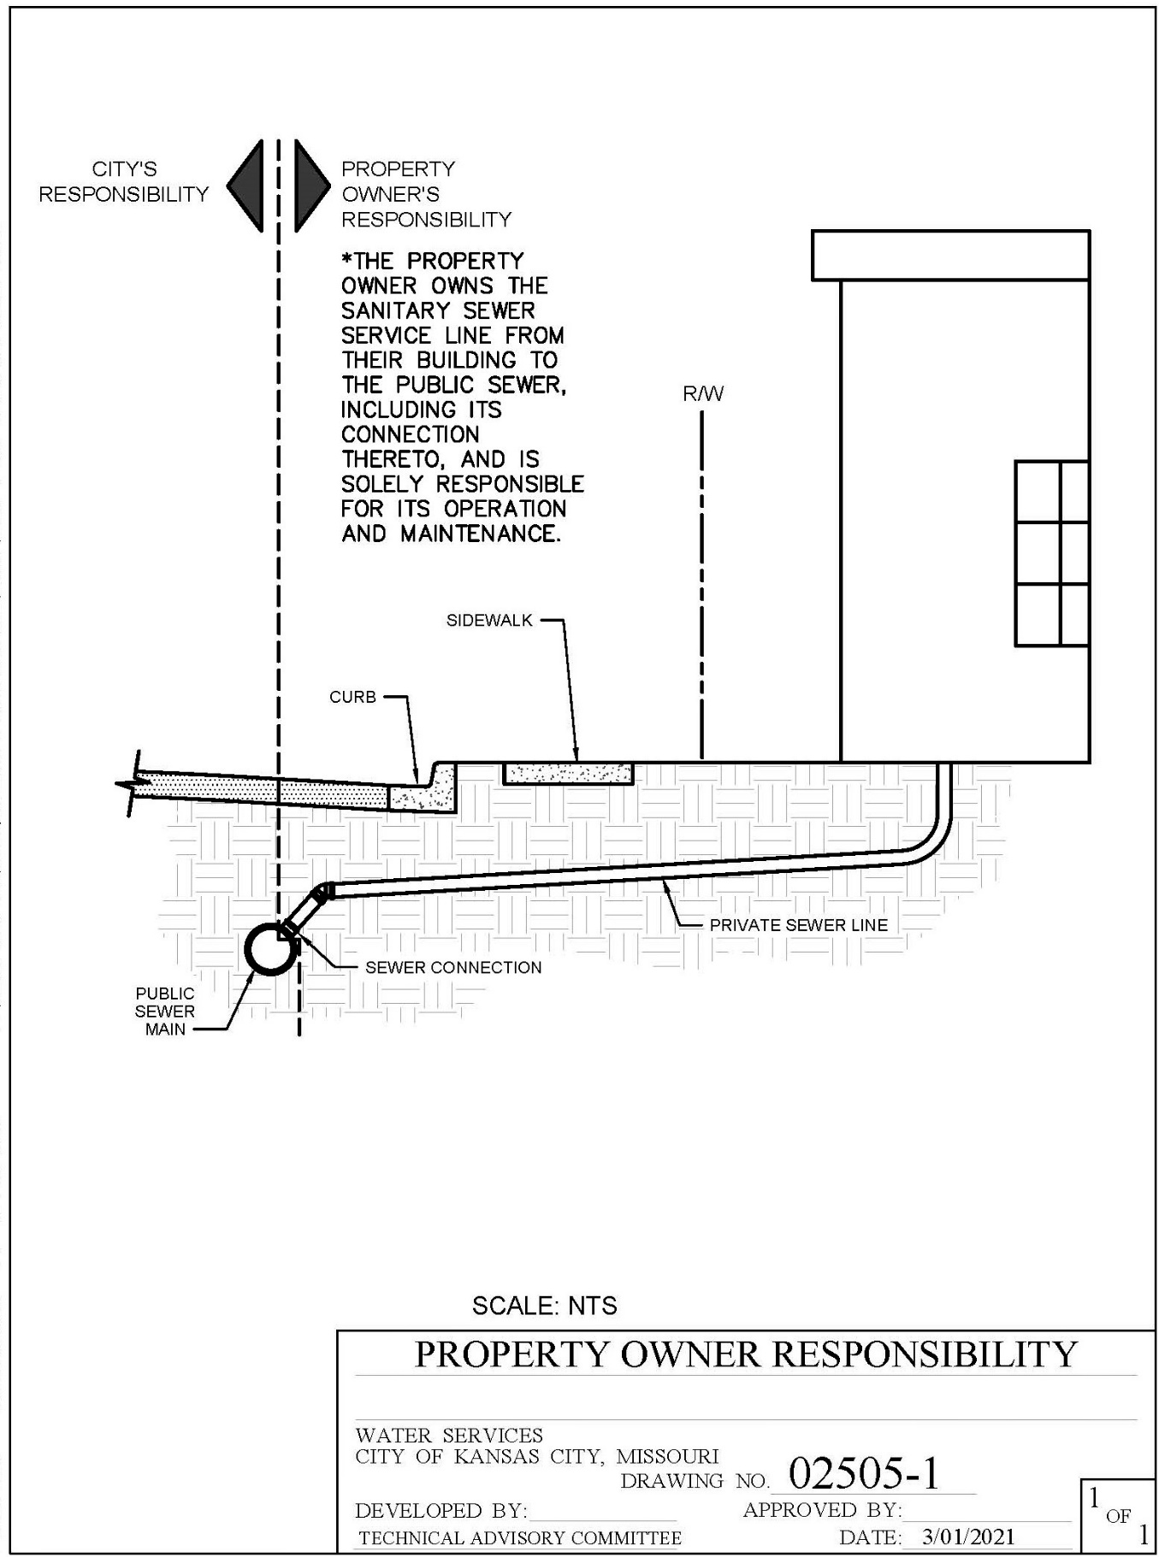

Figure 3.2

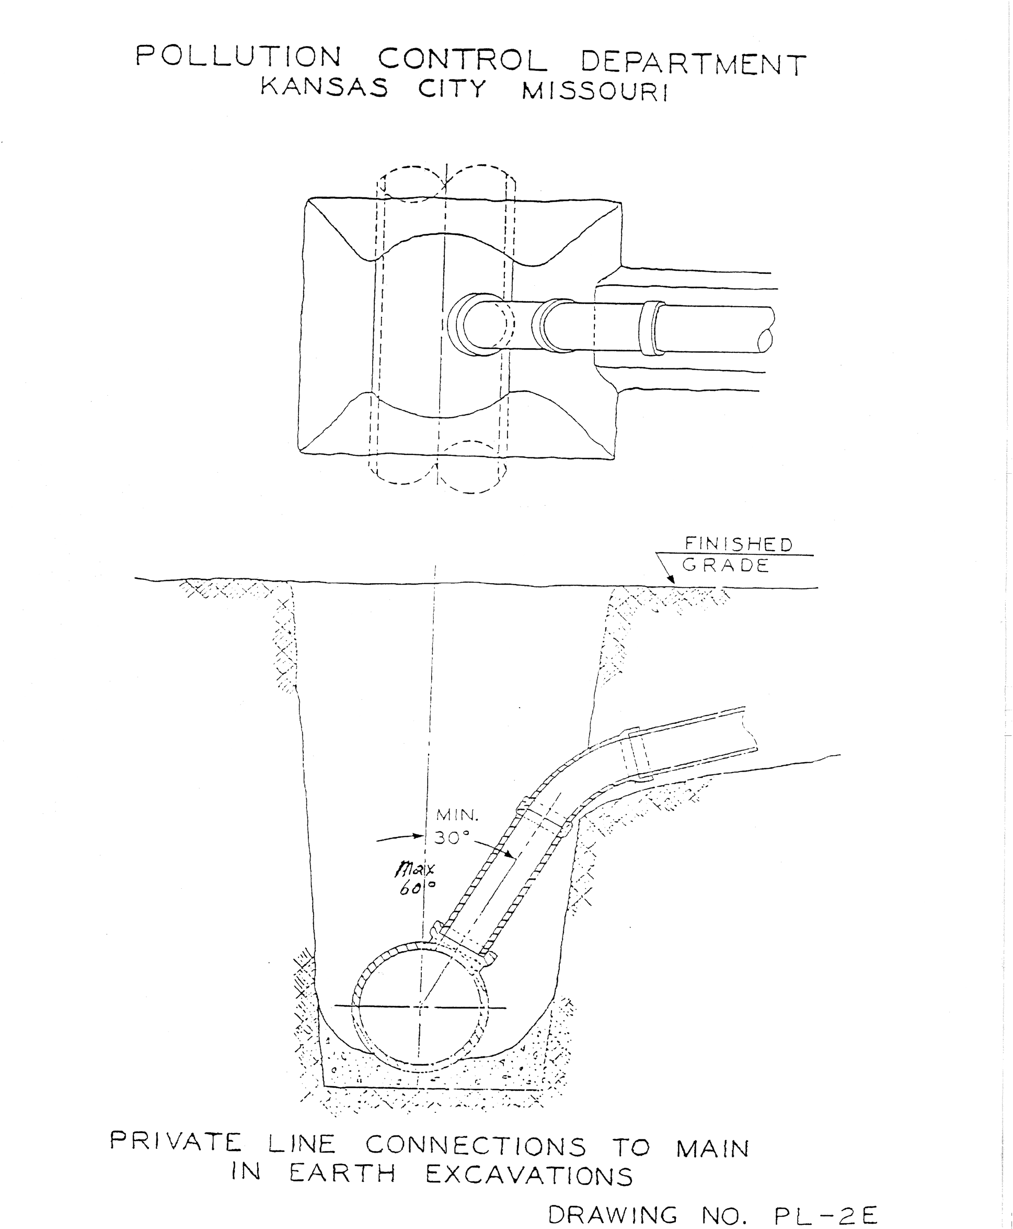

Figure 3.3
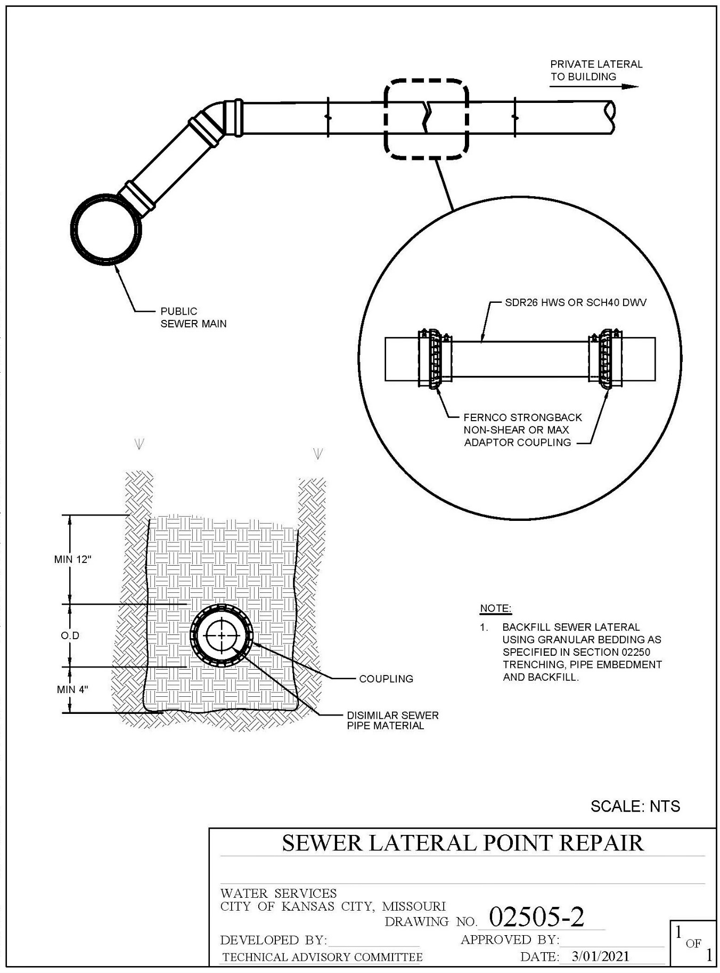

Figure 3.4
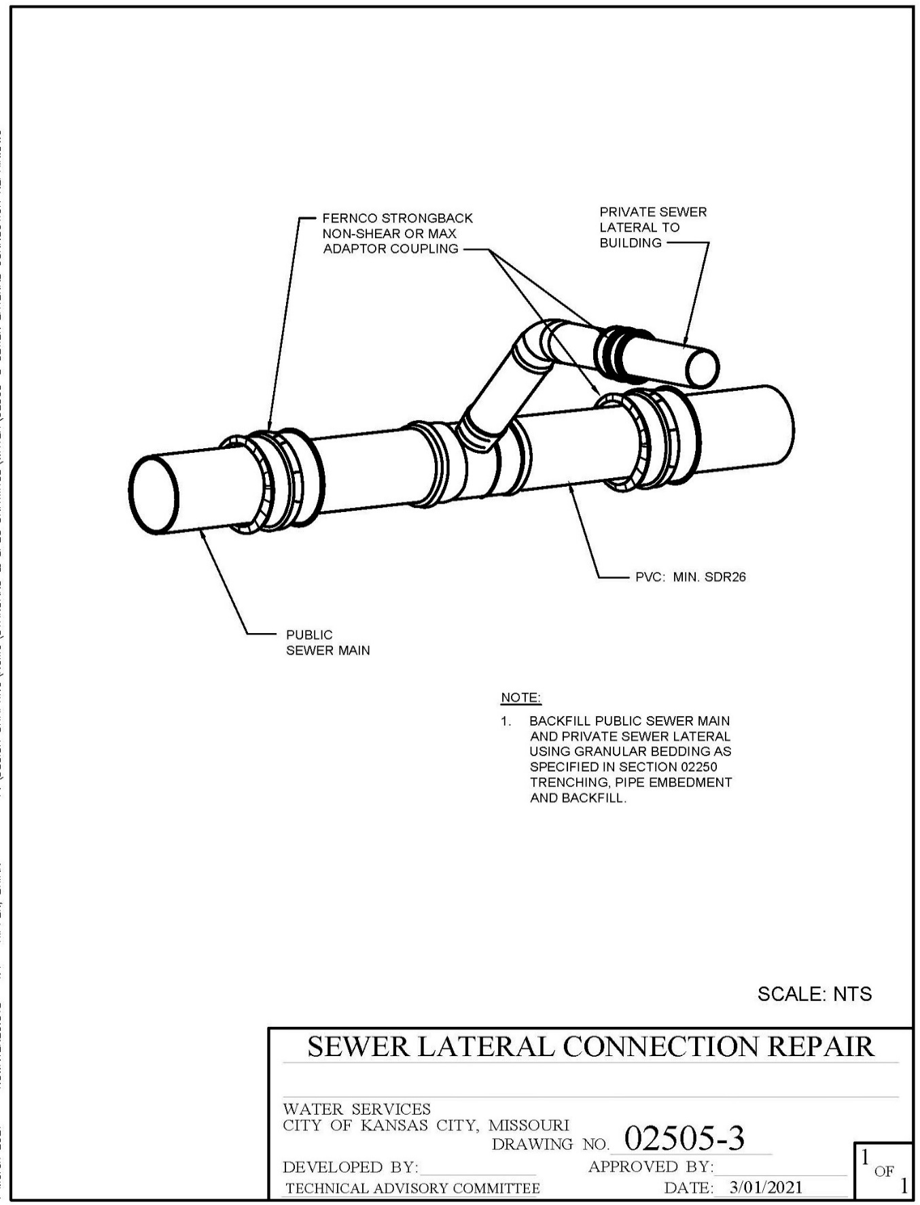

Figure 3.5

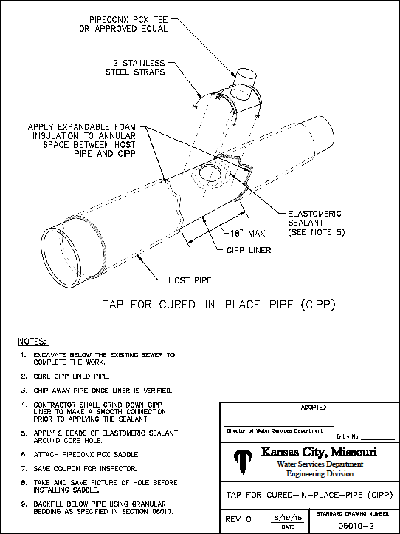

Figure 3.6

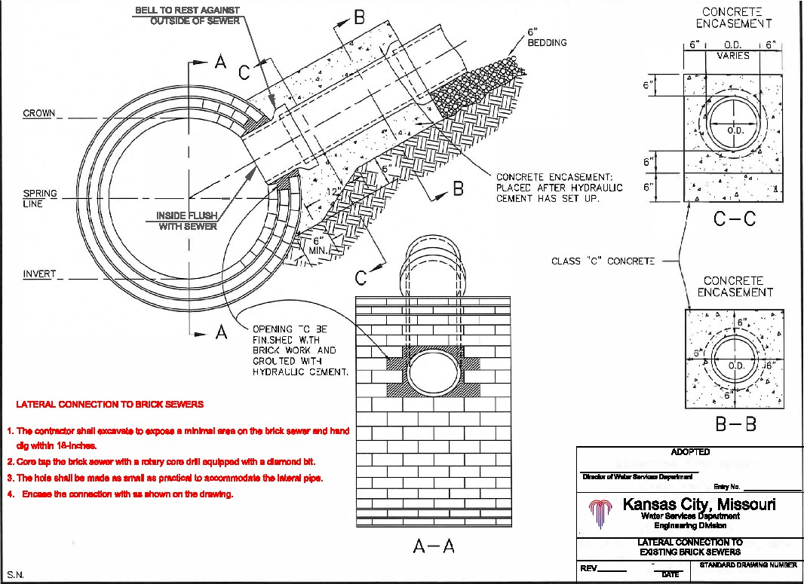

Figure 3.7
