Version 3.1 – Dec 2024

|  |
| --- |
|  |
| Water+ Cloud Customer Manual |
|  |

# Terms of Use

© 2022, Flowpoint Environmental Systems

All rights reserved. This software and related documentation are provided under a license agreement containing restrictions on use and disclosure and are protected by intellectual property laws. Except as expressly permitted in your license agreement or allowed by law, you may not use, copy, reproduce, translate, broadcast, modify, license, transmit, distribute, exhibit, perform, publish, or display any part, in any form, or by any means. Reverse engineering, disassembly, or decompilation of this software is prohibited.

The information contained herein is subject to change without notice and is not warranted to be error-free. If you find any errors, please report them to us in writing.

This software and hardware is developed for use in a variety of information management applications. It is not developed or intended for use in any inherently dangerous applications, including applications that may create a risk of personal injury. If you use this software or hardware in dangerous applications, then you shall be responsible to take all appropriate fail-safe, backup, redundancy, and other measures to ensure its safe use.

Flowpoint Environmental Systems and its affiliates disclaim any liability for any damages caused by use of this software or hardware.

Table of Contents

Terms of Use 1

Introduction 4

Logging In 4

Using the Manual 5

The Top Menu 5

Common Functions 5

Water+ Cloud Home 6

Feature Buttons 6

Status 6

Trucks 7

Adding a Truck 7

Editing Truck Information 8

Resetting a PIN 8

Stopping Water Sales to a Truck 8

Account Balances and Payments 9

Account Balances 9

Truck Transactions 9

Payments 10

Invoiced Customers 10

Prepay Customers 10

Making a Payment 10

Buying Water 11

Using the Access Terminal 11

Reports 12

Report Viewer Toolbar 14

Usernames and Passwords 15

Primary User 15

Adding a User 15

Editing a User 16

Deleting a User 16

Disabling a User 16

Changing Your Password 17

Changing Your Security Question 17

Resetting a Forgotten Password 18

Two-Step Verification Settings 18

Glossary of Terms 20

# Introduction

Water+ Cloud is an online application that works in combination with Flowpoint water dispensing stations (stations).

Water+ Cloud makes it easy for you to buy water, manage your trucks, view your account, and run reports.

## Logging In

Water+ Cloud can be accessed from any computer, with an internet connection, and a web browser.

Your Water+ Cloud web address is:

# Using the Manual

## The Top Menu

The instructions in this manual direct you to use the Top Menu headings and drop-down menus. This is just one way to access these features, you will discover other ways!



## Common Functions

|  |  |
| --- | --- |
| Function | Description |
|  | View or save the displayed information in Microsoft Excel format.  For Transaction Lists, PDF is also an option. |
|  | Search the field by entering the first characters of a word. |
|  | Update screen information |
|  | Save information and exit the feature |
|  | Exit the feature without saving. |

## Water+ Cloud Home

### Feature Buttons

Use the buttons on the home page to access application features:

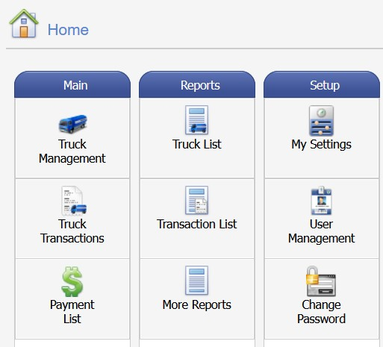

### Status

The status screen gives you an overview of your account activity:

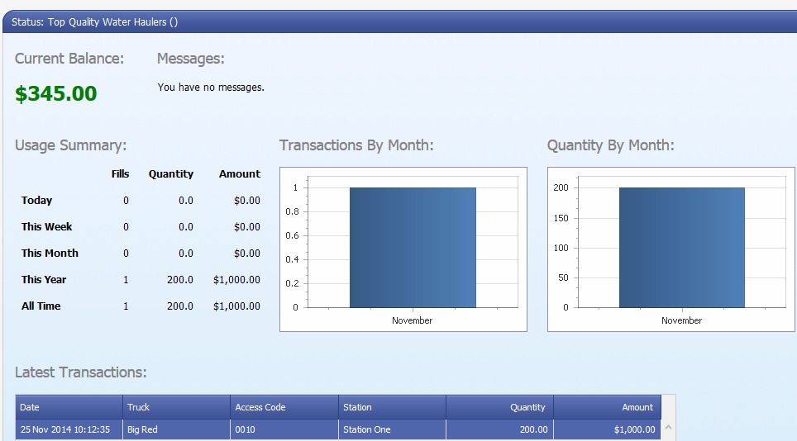

# Trucks

**Before you can buy water**, you must enter a truck record in Water+ Cloud. Each truck needs an access number and PIN to buy water at the station.

## Adding a Truck

Add a truck record in Water+ Cloud for each truck you own:

1. Point —>Trucks
2. Click —> Truck Management
3. Click —> New
4. Follow the guidelines below to enter truck details:



* indicates the field must contain information

| Field | | Description |
| --- | --- | --- |
| Access Number* | | Automatically assigned four digit number. If changed, you may get an error if the Access Number is already used. If so, try a new number. |
| PIN* (Personal Identification Number) | | Must be four digits . Drivers will remember the PIN if they choose it. |
| Truck Name * | | Truck number, or unique identifier |
| Description | | Could include, truck make and model, or other details you want to track. |
| Driver | Drivers first and last name. | |
| Plate # | Truck license plate number. | |
| Volume (U.S. Gal) | Capacity of the truck in U.S. gallons. | |
| This truck is Active | Remove the check mark to prevent a truck from using the station. | |

1. Click —> Save

## Editing Truck Information

To change truck information:

1. Point —> Trucks
2. Click —> Truck Management
3. Click to select the truck to edit
4. Click —> Edit
5. Change truck details
6. Click —> Save

## Resetting a PIN

Reset a forgotten PIN any time by:

1. Point —> Trucks
2. Click —> Truck Management
3. Click to select the truck to edit
4. Click —> Edit
5. Enter a new four-digit PIN
6. Click —> Save

## Stopping Water Sales to a Truck

To prevent a truck from buying water at the station:

1. Point —> **Trucks**
2. Click —> **Truck Management**
3. **Click to select the truck to edit**
4. Click —> **Edit**
5. **Click to remove the check mark beside *This Truck is Active***
6. **Click —> Save**

When a truck record is no longer active, the station will not accept the access number and PIN assigned to the truck.

# Account Balances and Payments

## Account Balances

The current balance displayed on the home page includes all payments and truck transactions received by Water+ Cloud.

Use the Payment List and Truck Transactions list to review details of both.

Feature buttons are available on the Home page:

#### Payment List

Shown for Prepay Customers only. The Payment List includes all payments processed against your

account.

### Truck Transactions

Truck Transactions list includes all water purchases made through your account.

## Payments

Payment methods are set by your water vendor and may vary between invoiced and prepay customers.

### Invoiced Customers

Information about frequency, due dates, and payment options are available from your water vendor.

### Prepay Customers

As a prepay customer you must maintain a balance in your account to buy water.

## Making a Payment

*For Prepay Customers only.* Payments can be made from the Make a Payment button on the home page or through the Payment List icon.

1. Click —>Make a Payment
2. Enter the payment amount
3. Click —> Submit Payment
4. Fill out the payment information (below)
5. Click —> Submit Payment

The eCommerce payment processor is set up by the Vendor therefore, each credit card page may appear different.  Credit cards accepted may vary by vendor.

# Buying Water

To buy water at a station, the driver will use an access terminal and fill hose.s

## Using the Access Terminal

Drivers enter their access number and PIN using an access terminal like the one shown below.

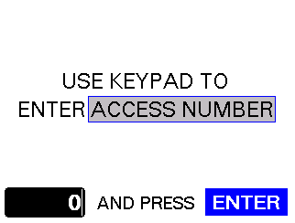

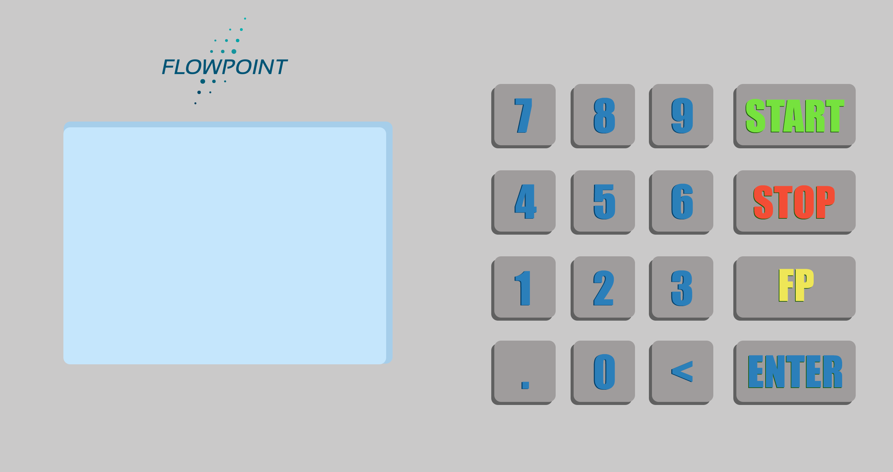

**Steps drivers follow to buy water:**

|  |  |
| --- | --- |
| 1. | Connect the water fill hose to the tank |
| 2. | Enter your four digit access number, press **ENTER** |
| 3. | Enter your four digit PIN, press **ENTER** |
| 4. | Enter the volume of water wanted, press **ENTER** |
| 5. | Confirm the hose is connected |
| 6. | Press **START** to start water flow   * Volume of water dispensing is displayed on the screen * The water will stop automatically once the requested volume is reached   Press **STOP** to stop water |

# Reports

1. Point —> **Reports**
2. Click —> **All Reports**

The following reports are available:

| Report | Description |
| --- | --- |
| Truck List | The truck list includes the following details for each of your trucks:   * access number * PIN * truck and driver name * status * plate # * capacity |
| By Truck (Transaction List) | Water purchase details for all or selected trucks between a start and end date |
| Transaction Summary (Transaction Summary by Station) | Water purchase details between a start and end date, grouped by station |
| Prepayments | Record of the money deposited to your account between a start and end date. |
| Service Charges | Service charges applied to your account between a start and end date. |
| Invoices | Your invoices, grouped by batch. |
| Invoice Summary | Transactions list by batch that includes year to date information. |
| Monthly Volume | Monthly breakdown of the quantity and cost of water bought. |

# Report Viewer Toolbar

|  |  |  |
| --- | --- | --- |
| Function | Description | |
|  | Search for a word or phrase | |
|  | Print the complete report | |
|  | Print the current page | |
|  | Scroll back | |
|  | Go to a page | |
|  | Scroll forward | |
|  | Select the file format for export | |
| PDF | Adobe Reader (default) |
| XLS | Microsoft Excel |
| XLXS | Microsoft Excel 2010 or newer |
| RTF | Rich Text Format |
| MHT | Mime Html |
| HTML | Hypertext Markup Language |
| TEXT | Plain text format |
| CSV | Comma-separated values |
| IMAGE | PNG picture format |
|  | Export and save the report to a file. | |
|  | Show the report information in the selected file format. | |

# Usernames and Passwords

A username and password allows you log in to Water+ Cloud to:

* view company, truck, and transaction information
* look-up, add, or change PIN’s
* add or edit truck records
* make prepayments (prepay customers)
* print reports

## Primary User

When you apply online for a Water+ Cloud account your username is the email address entered in your account application.

After your account is approved, an email message will be sent to you with password directions.

## Adding a User

You can add additional users for your company by:

1. Point —> **Setup**
2. Click —> **Website Users**
3. Click —> **New**
4. Enter information in the required User Details fields



* indicates the field must contain information

|  |  |
| --- | --- |
| Field | Description |
| Email Address/Username* | An email address (will be the username) |
| First Name * | First name of user |
| Last Name * | Last name of user |
| New Password | Type a password, 8 characters or more |
| Confirm Password | Type the password again |
| Locked | Set to Locked to deny login access |

1. Click —> Save

## Editing a User

To edit user information:

1. Point —> Setup
2. Click —> Website Users
3. Click to select the username to edit
4. Click —> Edit
5. Make changes
6. Click —> Save

## Deleting a User



Drivers without a username can still buy water

When you delete a username, you stop the user from logging in to Water+ Cloud.

To delete a username:

1. Point —> Setup
2. Click —> Website Users
3. Click to select the username to delete
4. Click —> Delete
5. Click —> Confirm

## Disabling a User

Lock an account to prevent a user from logging in to Water+ Cloud without deleting their username:

1. Point —> **Setup**
2. Click —> **Website Users**
3. Click to select the username to lock
4. Click —> Editfrom the Website Users menu
5. Click in the blue box beside Locked to add a check mark
6. Click —> Save

## Changing Your Password

Passwords must be a minimum of 8 characters in length and contain:

at least 1 letter (a-z or A-Z)

at least 1 number (0-9)

at least 1 special character (!, @, $, ?, etc)

To change your password while logged in:

1. Point —> Account
2. Click —> Change Password
3. Complete the password change fields following these guidelines:



|  |  |
| --- | --- |
| Field | Description |
| Old Password | Enter your current password |
| New Password | Enter a new password, that is 8 characters or more |
| Confirm Password | Enter the new password again |
| Security Question | This question is asked when the *I Forgot my Password* feature is used. You do not have to change this information |
| Security Answer | Leave blank unless you changed your security question |

1. Click —> Change Password

The new password is saved and ready for use!

## Changing Your Security Question

1. Point —> Account
2. Click —> Change Security Question
3. Enter your new security question and answer
4. Click —> Save

## Resetting a Forgotten Password

Reset your password with the *I Forgot my Password* feature on the Water+ Cloud site:

1. Go to the Water+ Cloud site
2. Click —> **Log in to Water+ Cloud**
3. Click —> **I forgot my password**
4. Type your email address
5. Click —> **Submit**

** Be prepared to answer your security question

1. Answer the security question
2. Type the displayed security code
3. Click —> Email password information

## Two-Step Verification Settings

If Two-Step verification is required, an Email and/or SMS/Mobile Phone Number can be added. If the Two-Step Verification is enabled, a notice will appear below the checkbox indicating that the security code must be entered the next time the user logs in (at this point the user is already validated).

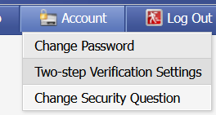

By default, *Send By Email* is selected, but the user can also enter their mobile phone number.

1. Point —> Account
2. Click —> Two-Step Verification Setting

|  |  |
| --- | --- |
| Field | Description |
| Two-step Verification | Enables two-step verification. |
| Email | User email |
| SMS/Phone Number | User SMS/Mobile Phone Number |

1. Click —> Save

When the customer logs in, they will receive a message asking where to send their security code. They can choose to send it by email and/or text message (if a phone number is entered). Once they click the button, the message to the right will appear. As shown, the security code is valid for 14 minutes.

If *Don’t ask again**on this device*box ischecked, it will remember the device. If they log in using a different device, they will have to enter a new code.

If they don’t receive the code, they have the choice to send a new code.

# Glossary of Terms

**Access Number:** four-digit identification number assigned to a customer truck. Access number is used in combination with a PIN to buy water.

**Access Terminal:** keypad and screen at the station. Customers enter their access number and PIN on the access terminal.

**Account:** a customer must have an account to have an access number and PIN. Customers can have an invoice or prepay account.

**Communication Link**: cellular network connection between the access terminal and Water+ Cloud.

**Download:** copies new customer, prepayment, and truck details from Water+ Cloud to the access terminal.

**Measurement Unit:** the measurement used to dispense water. Choices are: U.S. Gallons, Imperial Gallons, Cubic Feet, Cubic Meters, or Barrels.

**PIN (Personal Identification Number):** four-digit password used with an access number to buy water at a station.

**Synchronization:** copies information between the access terminal and Water+ Cloud.

**Upload:** copies transaction details from the access terminal to Water+ Cloud.

**Water Dispensing Station (Station):** dispenses water to customers. A combination of an access terminal, water fill hose, and communication link.

**Water Fill Hose:** hose that dispenses water into the tank. The amount of water is controlled by the access terminal.